Mary Bryden 1953-2015

Tribute Day at the University of Reading

5th November 2016

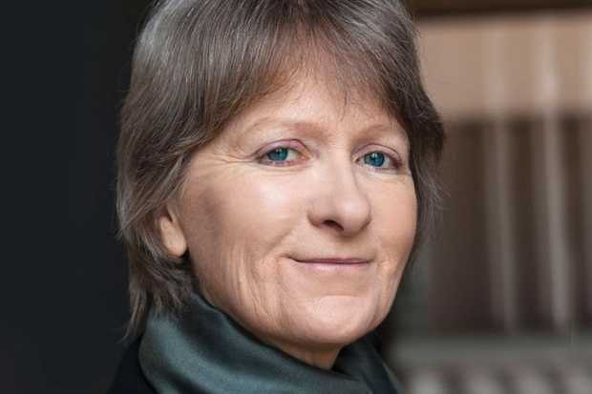

Mary Bryden was Professor of French Studies and Co-Director of the Beckett International Foundation at the University of Reading until her retirement due to ill-health in 2012. Sadly our beloved friend and colleague died on 5th November 2015. On 5th November 2016, at the Minghella Studios on the Whiteknights campus of the University of Reading, Mary’s family, friends and colleagues will gather to remember Mary and to celebrate her life and work.

PROGRAMME

11am – 12 noon: Minghella Studios (First Floor)
A pop-up exhibition featuring materials from the Billie Whitelaw Beckett Archive, acquired by the Beckett International Foundation in December 2014, will be available to view in the Studio Space.

12 – 1pm: Minghella Studios
Emeritus Professor James Knowlson will give a lecture on ‘Beckett and Billie’ about the enduring friendship and creative collaboration between Samuel Beckett and Billie Whitelaw. Mary was involved in Billie Whitelaw’s visits to the University of Reading as the inaugural Annenberg Beckett Fellow in 1992 and when she received an Honorary Degree of Doctor of Letters from the University in 2001.

1 – 2pm: Lunch in the Minghella Foyer, hosted by the University of Reading

2 – 3.15pm: Room G10, Palmer Building, Whiteknights Campus
This section of the tribute day features musical and other tributes relating to Mary’s interests.

- Edana Minghella will sing 4 Billie Holliday songs from her latest album, All or Nothing. The Minghella Studios are named after Edana’s brother, the director for film, theatre and television, Anthony Minghella.
- Dr Daniela Caselli (University of Manchester): ‘Dante – Theory - Gender’
- Dr John McKeane (University of Reading): ‘Beckett and France’
- Professor Matthew Feldman (Teesside University): ‘Mary, Modernism and Religion’
- Dr Mark Nixon: ‘Mary, Beckett and the Archive’
- Edward Beckett will play the flute accompanied by his son Chris Beckett: Fauré ‘Morceau de concours’ and von Paradis, Sicilienne.

3.30 – 5pm: Minghella Studios
Personal Tributes chaired by Dr Julia Waters (French Studies, University of Reading)
- Francoise le Saux, French Studies (University of Reading)
- Emeritus Professor James Knowlson (University of Reading)
- Emeritus Professor John Pilling (University of Reading)
- Professor Anna McMullan (University of Reading) will read a tribute from the Samuel Beckett Research Circle of Japan and from the composer Paul Rhys, (Anglia Ruskin University)
- Prue Gillett, actor, voice coach and close friend of Mary’s, will deliver a tribute and read a collection of Mary’s creative writing that she has chosen.

5-6.30pm: Minghella Foyer
Wine Reception

