Results of the questionnaire associated with the webinar on “Responses and adaptation of cocoa to a variable and changing climate” held on 23rd October 2024, hosted by the University of Reading
Introduction & background of participants
The questionnaire was made available to webinar participants on registration and during the webinar. In total, 61 participants responded to the questionnaire (although the numbers answering different questions varied). About half of the respondents worked in academic/ research roles, whilst just under a third worked in the cocoa and chocolate industries. Other groups represented in much smaller numbers included farmers/ farmer organisations, government agencies, traders and an NGO (Figure 1). The geographical distribution of the participants was global, with West Africa, South America and Europe being particularly well represented (Figure 2).

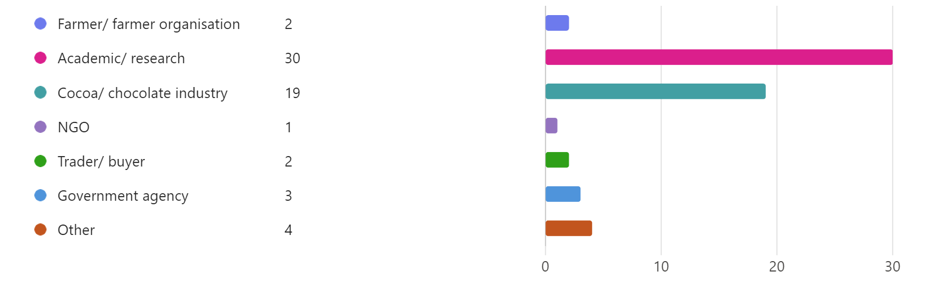Figure 1: Summary of the background of webinar participants

Figure 2: Geographical distribution of webinar participants
Perception of impacts of climate change on cocoa production
Many participants highlighted that they have already observed changes in climate in cocoa-growing areas including more extreme high temperatures (and sometimes low night temperatures), more extreme rainfall (high rainfall events and more intense droughts) and less predictable weather patterns. Stronger winds were also mentioned by some respondents.
In terms of direct impacts on cocoa, reduced and more variable yields was frequently highlighted as an issue. Other impacts included reduction in pod size, flower and fruit abortion. Tree losses, particularly at the seedling establishment phase was also highlighted as a particular issue. Indirect impacts were also mentioned, most notably on pests and diseases.
Some respondents also raised socio-economic impacts such as financial instability of farmers and a consequent inability to invest in inputs.
Strategies that could be adopted to lessen the impacts of high temperatures and/ or prolonged droughts on cocoa production
Selection and breeding of cocoa varieties that are more resilient to stresses such as high temperature and drought was a commonly cited strategy, mentioned by almost half of recipients. Agroforestry/ planting more shade was suggested by a number of participants as a means of protecting the crop against weather extremes as well as a way of diversifying incomes. Another approach mentioned by several participants was better water management through for example, rainwater harvesting, irrigation and use of mulches. The importance of soil health was highlighted by a number of respondents, for example, application of organic matter to improve soil water holding capacity and the use of selective fertilisers to promote root growth.
In order to translate these strategies into practice, the need for farmer education and support was highlighted by several respondents as was the importance of robust policies (for example, against deforestation).
Perceptions of the impacts of agroforestry on the microenvironment
Most respondents either agreed (62%) or strongly agreed (34%) with the statement that: “shade/ agroforestry can mitigate high temperatures”. No respondents disagreed with this statement (Figure 3). When it came to perceptions of the impact of agroforestry on water availability 28% and 46% of respondents, respectively, agreed or strongly agreed with the statement that “shade/ agroforestry can mitigate the effects of drought”. A small proportion of respondents (5%) disagreed with this statement, with the remainder (21%) neither agreeing nor disagreeing (Figure 4).
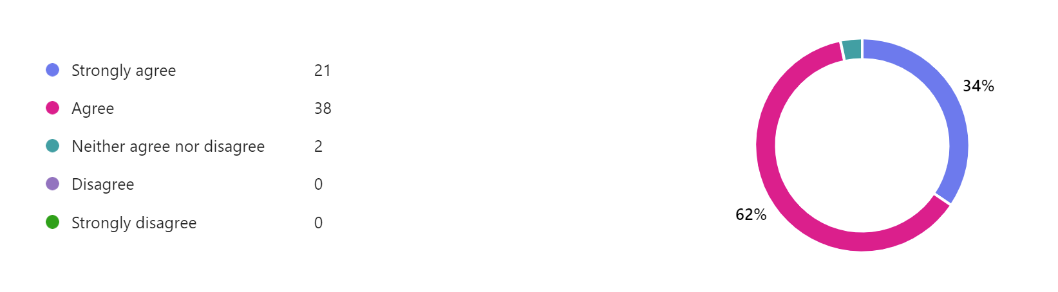Figure 3: Responses to the statement “Shade /agroforestry can mitigate high temperatures”

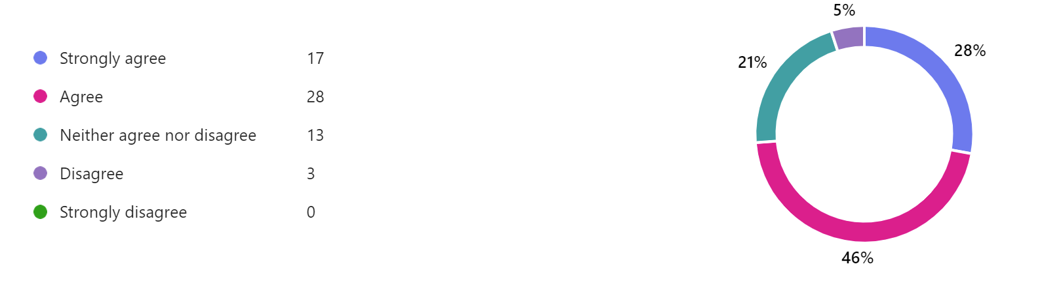
Figure 4: Responses to the statement " Shade/ agroforestry can mitigate the effects of drought”
Other benefits of agroforestry
In addition to ameliorating the microenvironment, other benefits cited by respondents included additional income (e.g. from timber trees) and better food security through crop diversification. Improved biodiversity including potentially providing hosts for pollinators was also a key issue highlighted. Various ways in which agroforestry can improve soil health were noted by a number of respondents, including improved soil organic matter content through leaf fall, better soil physiochemical properties, improved soil fertility, and the potential for nutrient recycling if deep rooted species are used. The ability of larger trees to act as a wind break was mentioned as a benefit.
Drawbacks of agroforestry
In citing potential drawbacks of agroforestry, many respondents highlighted the need for well managed systems to avoid unintended consequences, for example, yield reduction under heavy shade and the potential to host pests and/ or diseases if inappropriate trees are used. The issue of illegal tree felling was also highlighted, particularly as such activities can have a destructive impact on cocoa trees. Labour availability and financing were other challenges raised associated with cocoa agroforestry systems.

