IFNH NEWSLETTER | SPRING 2018
OUR TEAM HAS GROWN
Yvonne McMeel has recently joined the team as KIC Partnership Manager, working with Kate Green to support and develop multi-disciplinary collaboration across the University.
Three Post-Doctoral Research Fellows - Ese Omoarukhe, Natalie Masento and Simona Grasso, have also joined the Institute for Food, Nutrition and Health in recent months.

Read more

CALL FOR PROPOSALS FOR ACTIVITIES TO BE EXECUTED IN 2019
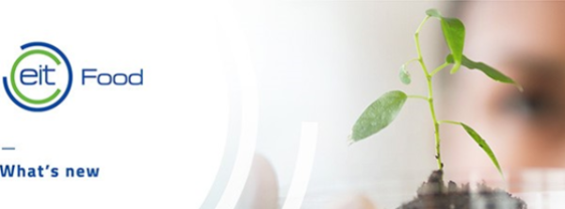

Colleagues from across the University contributed to first stage submissions to EIT Food, for projects to be delivered in 2019. From 142 proposals in the pre-call, 20% more than last year, University of Reading is involved in 39 proposals, 12 as a lead organisation and 27 as a partner.

Read more
INNOVATION MARKETPLACE & INAUGURATION OF EIT FOOD
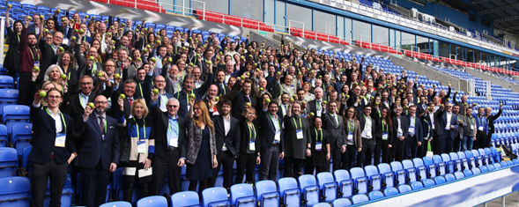

Across two days, an exceptional mix of innovation managers, top academia, business leaders, entrepreneurs, food scientists, technology experts and societal opinion makers met at Reading’s Madejski Stadium to discuss the development of new projects in the areas of education, innovation, business creation and consumer outreach, setting milestones together in order to prepare for the future of our European food sector.

Read more

THE CENTRE FOR DAIRY RESEARCH (CEDAR) NAMED AS LEAF INNOVATION CENTRE
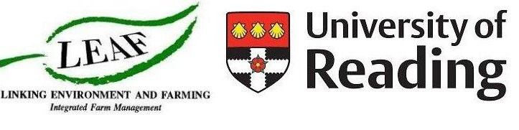
The Centre for Dairy Research (CEDAR), at the University of Reading has been named an Innovation Centre by LEAF (Linking Environment and Farming), the leading organisation promoting more sustainable farming.
Read more

TALKING TO AN EMPTY ROOM? (NEED SOME MARKETING PLANNING IMAGE)

We (Research Communications) want to talk about your research. We want to help you find ways to showcase your innovations and raise your profile and reputation. We want to equip researchers to communicate well and help you connect with the right audiences and networks to influence change. Importantly it’s not just a question of what to say, but to whom you are saying it to.
By Tim Yates,
Research Communications Business Partner

Read more

