Students turn food waste into business ideas

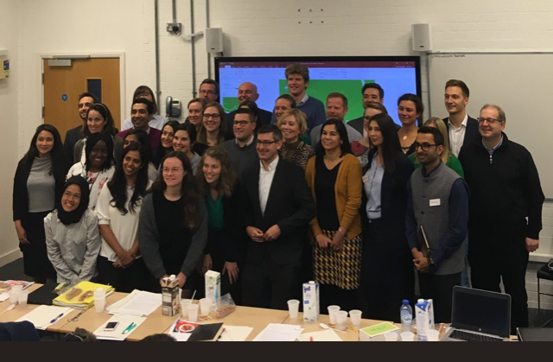

A student competition has seen food waste – bread, bananas, and potatoes – turned into business opportunities.
The Circular Food Generator Track project, funded by EIT Food, saw student teams from the University of Reading, University of Hohenheim and KU Leuven develop ideas to create new products reusing bread, bananas and potatoes.
Read more

University of Reading team win Young Entrepreneurs Scheme (YES) Finals!!

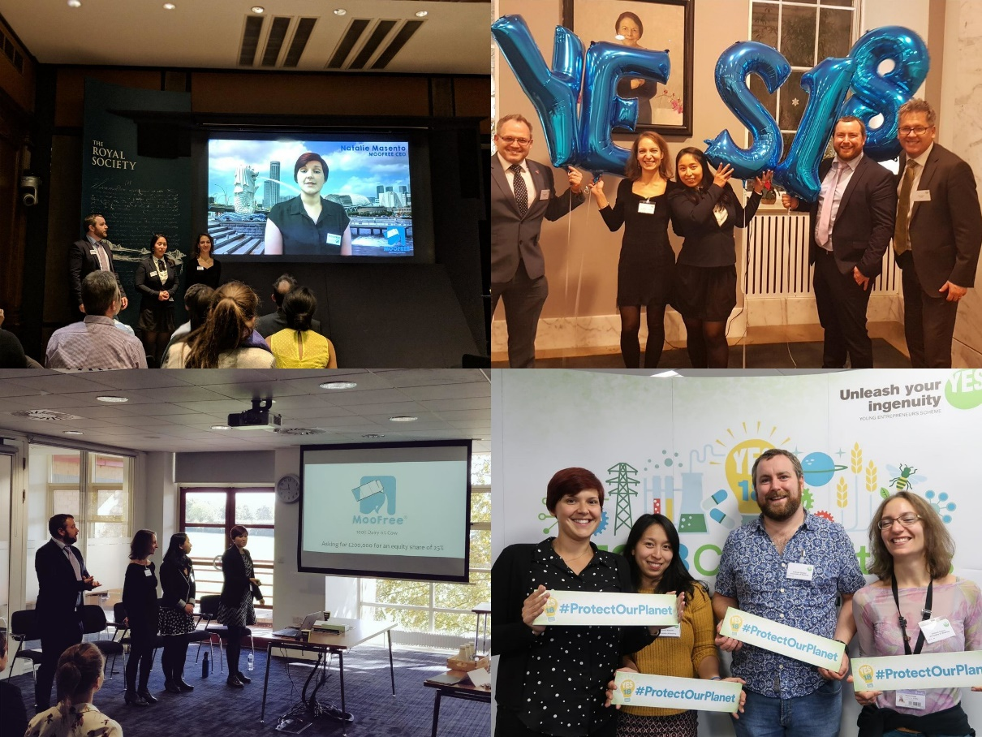
A team from the University of Reading have won two prizes in the final of the Young Entrepreneurs Scheme 2018.
Team MooFree won both the People’s Award and the overall Environment YES Prize at the YES18 final on the 11th December.

Read more

Food Matters Live 2018
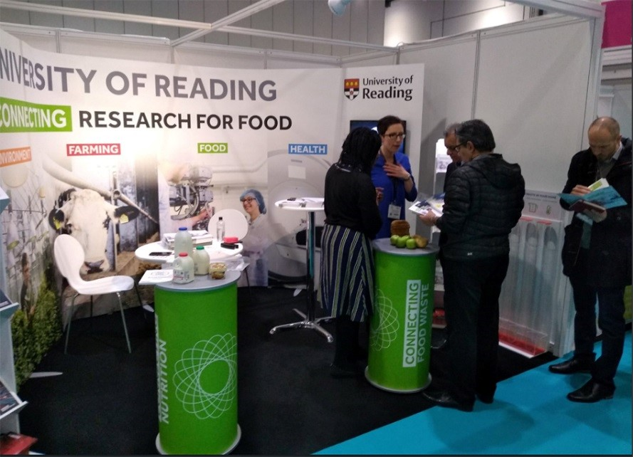
The University of Reading stand at Food Matters Live 2018 at the ExCeL Centre in London highlighted our strong research connections between food, farming, environment and health and how these are making a difference to food consumers and businesses.
The IFNH staff team supported this event, speaking to many companies and members of the public and media. Professor Ian Givens, Director of the Institute added his expertise to the event’s series of talks about the future of food.

Read more

Food Ambassadors - Food and Health Forum Event
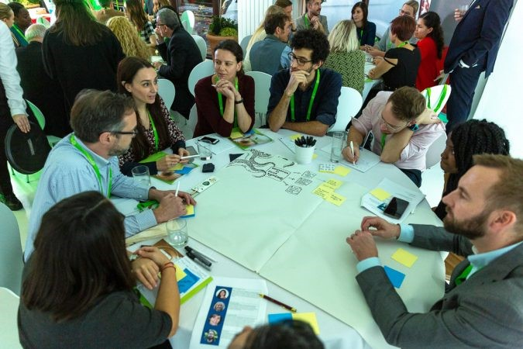

An EIT Food event in London examined ‘food systems of the future’, which was attended by key ‘food and health influencers’. Some of the questions the participants at the forum considered included the following - what are the major challenges in the food system, how can we address them and what gaps exist between issues such as personalised nutrition, food innovation and sustainability and potential solutions?

Read more

IFNH first Anniversary -‘Translational nutrition: from research to real life’
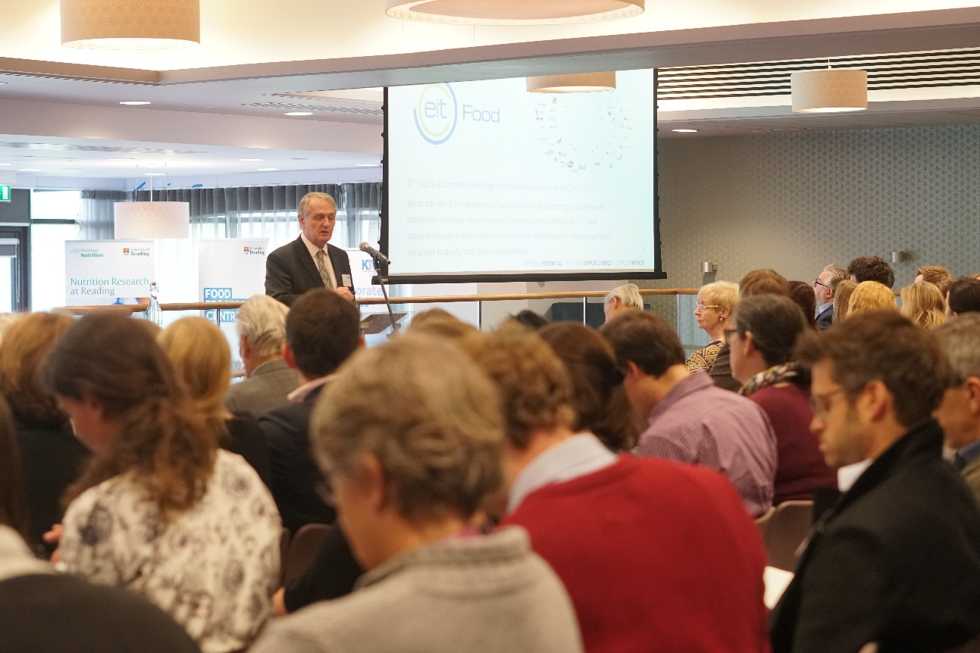

The Institute for Food, Nutrition and Health recently celebrated its first anniversary with a 1 day conference themed around ‘Translational nutrition: from research to real life’.
Colleagues from across the University joined with valued external stakeholders from a wide range of organisations to hear from a diverse range of speakers, covering areas as broad as gamification, personalised nutrition, sustainable dairy production systems and food insecurity.

Read more

Merry Christmas and best wishes for a Happy New Year filled with health, happiness and spectacular success!
IFNH Team
