L to R: Dr Andrew Bennett (President, Tropical Agriculture Association, Dr Nigel Poole (ICRISAT Ambassador), Prof. Robert Van de Noort (VC), Dr Rajeev Varshney (ICRISAT), Prof. Ian Givens (IFNH Director) and Prof. Julian Park (Head, School of Agriculture, Policy and Development).
We are very pleased to announce that a Memorandum of Understanding was signed (above) on the 14th November between the IFNH and ICRISAT (International Crop Research Institute for the Semi-Arid Tropics). ICRISAT is an international non-profit organisation that conducts agricultural research to bring prosperity to the small holder farmers in the dry lands of Asia and Africa. This new partnership will facilitate collaborative research focused on tackling how crops will provide a healthy and sustainable diet for future generations that face multiple challenges including climate change and growing worldwide obesity.
Read more
Influencing Behaviour Change
2nd Annual IFNH Forum 30th October
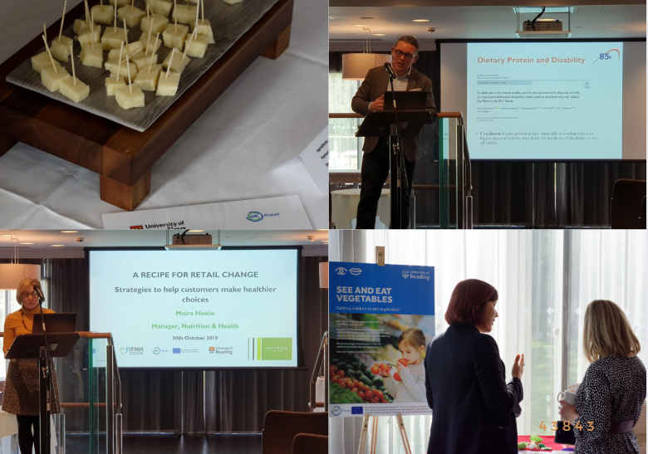

After another successful year of activity, the IFNH recently celebrated its 2nd Annual Forum. The ‘Influencing Behaviour Change’ theme focused on research and development activities the University and its partners are undertaking to address the challenge of making improvements to aspects of our food and health systems with the ambition of enhancing nutrition, food security, sustainability and human health.
The 2nd Annual Forum explored wide-ranging outputs from a number of collaborative projects, including encouraging the adoption of technologies and innovations by farmers; encouraging young children to eat vegetables; wearable sensors for people with Parkinson’s Disease and the strategies employed by retailers to support consumers to make healthier food choices. The speakers included a range of academics from across the University as well as Moira Howie, Manager of Nutrition & Health at Waitrose & Partners and Professor Thomas Hill, Chair in Nutrition at Newcastle University.
Many thanks to all those that were able to join us, and we look forward to seeing you at our next Forum on the 28th October 2020.

Avoid the sprout fights with your kids at Christmas!
Familiarising kids with vegetables through eBooks
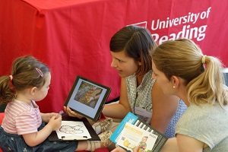
Dr Natalie Masento has been busy talking to the media about the great new initiative to encourage young children to eat vegetables.
The See & Eat eBooks were developed by a project team led by Prof Carmel Houston-Price to support parents and carers to encourage their children to eat more vegetables through a farm to fork journey of different vegetables personalised with pictures, videos and text. Twenty-four new eBooks available in English and Italian are now free to download and the project will launch three further languages editions next year.
The project has been funded by EIT Food and our partners include University of Torino, The European Food Information Council (EUFIC), the Open University and the Colruyt Group.
Read more

FOOD4HEALTH CROSS - KIC PROJECT
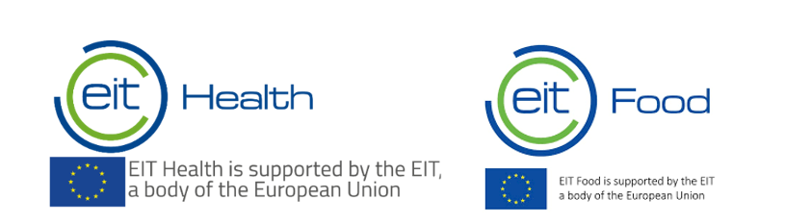
Food4Health is a new collaboration between EIT Health and EIT Food. The two networks have come together to develop a joint strategy, build a shared portfolio in the overarching area of food for health and engage their respective partners in combined activities. The University of Reading successfully applied to help deliver the STOP MetSyn project. This project aims to develop indicators to influence consumer behaviour and prevent pre-disease of the irreversible Metabolic Syndrome through food and lifestyle-related interventions
We are pleased to be working with partners across EIT Food and EIT Health, including the Erasmus Medical Centre (NL), Hospital Sant Joan de Déu (ES), Institut Català de la Salut (ES), KU Leuven (BE), OME Health (UK), Pepsico (UK), RISE (SE), University of Ghent (BE), and Universidad Politécnica de Madrid (ES).

EIT Food
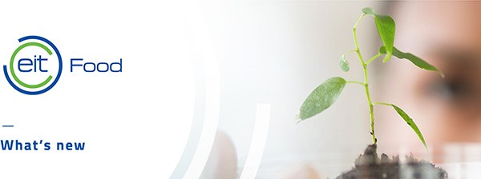
EIT Food has recently published its Annual Report for 2018.The report gives an overview of activities and the impact achieved in helping to build better food systems across Europe. It also includes success stories from different regions, showcasing the activities and achievements of projects delivered in 2018.
We expect the next call for EIT Food projects - to be delivered in 2021 - to be released in the New Year. We will share with IFNH members and run information workshops.
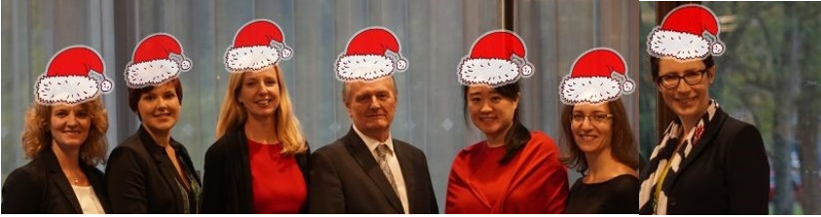
Merry Christmas and best wishes for a Happy New Year filled with health, happiness and spectacular success!

