IFNH NEWSLETTER | SPRING 2018
PROFESSOR IAN GIVENS
DIRECTOR, Institute for Food, Nutrition and Health
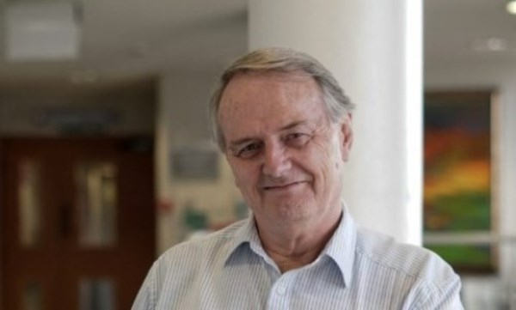

I am delighted to introduce our first IFNH Newsletter. This will be your regular source of IFNH news and information, including updates on EIT Food as well as other opportunities and initiatives.
2018 promises to be a very exciting year and myself and the team look forward to working with many of you to drive forward innovation and collaboration. I encourage you to take the time to have a look at our website, read about the IFNH mission and vision, and become part of our growing University Community. Register today to receive regular updates and communications, including information on potential funding opportunities.
Read more

EIT FOOD - SUCCESS FOR READING IN EU INNOVATION FUNDING
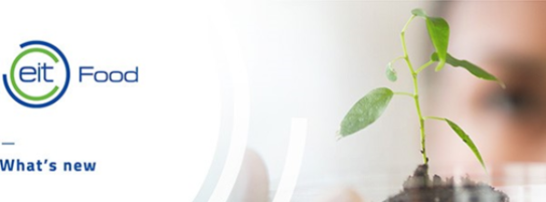
Innovative projects to change the way we produce, distribute, consume and value food will kick off this month as part of the University’s engagement with EIT Food - the EU innovation programme and consortium.
Read more

Leading food industry partners to visit the University

On the 21st and 22nd February the EIT Food Innovation Marketplace will be taking place in Reading (at the Madejski Stadium). This is an opportunity for all EIT Food partners to come together to discuss and develop ideas for the next project call as well as to hear important, formal updates from the EIT Food Management Team.
Read more

DEVELOPING AN INNOVATION ROADMAP FOR CLIMATE CHANGE ADAPTATION
A wide range of stakeholders came together in Brussels in December to talk about the action and innovation that is required to effectively respond to the challenges of climate change adaptation across much of Europe. Once project reports have been approved, we will hold a lunchtime seminar to share project findings with colleagues.
Read more

The role of dairy products and type 2 diabetes risk: where does the evidence stand?
Professor Ian Givens and Dr Sarah Jing Guo are taking part in an exciting project funded by the Dutch Dairy Association and Friesland Campina, aimed at pulling together the evidence that examines the links between dairy products and the risk of Type 2 diabetes.
Read more

Upcoming IFNH NEWS AND events
We will soon share with you further updates for our events and seminars scheduled for 2018. Also, if you have exciting news and projects in your School/department, please contact Elena Carp (e.carp@reading.ac.uk), and we are happy to include the information in our next Newsletters.
If you would like to opt out of receiving future Newsletters, please email Elena Carp.

Copyright © | 2017 | IFNH | All rights reserved.
Our mailing address is:
ifnh@reading.ac.uk
Want to change how you receive these emails?
You can update your preferences or unsubscribe from this list.

