

**Influencing Behaviour Change**  
**2nd Annual IFNH Forum 30th October**



Significant research and development activity focuses on making improvements to aspects of our food and health systems with the ambition of enhancing nutrition, food security, sustainability and human health. The outputs of these activities are wide ranging, including for example, new products, new technologies and improved information provision. However, real impact from these advancements can only be achieved if sufficient attention and effort is focused on enabling the end beneficiaries, whether they be consumers, farmers or food industry organisations, to make sustained use of these outputs. Influencing behaviour change is a massive challenge, which all those striving to make improvements in our food and health systems, need to address.  
  
The **2nd Annual IFNH Forum** looks to explore this challenge in detail, involving diverse inputs highlighting work across a broad range of areas.  
  
The Forum will be a free one-day event which will take place on **Wednesday 30th October 2019 at the University of Reading, Meadow Suit, Park House.** More information including the programme and registration link to follow.

**EIT Food Projects**



Colleagues from across the University contributed to the **EIT Food Call for Proposals for projects to be delivered in 2020**. We are very pleased to confirm that 54 proposals have been submitted across all 4 themes of Education, Communication, Innovation and Business Creation. Many thanks to all those involved for their hard work in getting the proposals submitted and fingers crossed for good news.  
  
**2019 EIT Food Projects** have started well and Reading academics are collaborating with industry, research institutions and other universities in 28 newinnovation, communication and education projects with a total project value of €3m. These projects draw on the University’s broad expertise in food, nutrition and health and involve a diverse range of disciplines from Schools across the University. For details about current projects, please see <https://research.reading.ac.uk/ifnh/research/eit-food/>

**Testing Zombie Attack Games of Foods with Year 7 students**

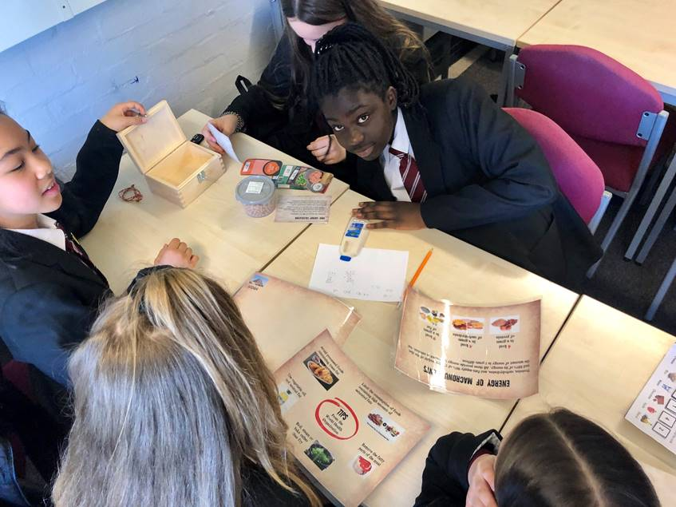

|  |  |  |  |
| --- | --- | --- | --- |
| |  |  |  | | --- | --- | --- | | |  |  | | --- | --- | | |  | | --- | | [**Read more**](https://research.reading.ac.uk/ifnh/2019/03/22/zombie-attack-during-british-science-week-2019/) |   Dr Natalie Masento (Post-Doctoral Research Fellow) was able to share the Zombie Attack Game of Food with two Year 7 classes from the Brakenhale School and the Blessed Hugh Faringdon during British Science Week.  Zombie Attack, an escape room based game that teaches about protein was designed with other EIT Food partners during 2018 and tested with University students with success in encouraging new nutrition knowledge and motivation to learn about protein.  This year the EIT Food funded project will be taking Zombie Attack to secondary school classrooms to determine how the escape game is received by children aged 11-14 years old and whether they show similar results of improved knowledge and interest in learning about nutrition and health. | | |

|  |
| --- |
|  |

**Trust in our Food – a free Massive Open Online Course (MOOC)**



|  |  |  |  |
| --- | --- | --- | --- |
| |  |  |  | | --- | --- | --- | | |  |  | | --- | --- | | |  | | --- | | [**Read more**](https://research.reading.ac.uk/ifnh/2019/05/15/7651/#more-7651) |   The successful ‘Trust in our Food’ MOOC, developed by the School of Agriculture, Policy and Development, in collaboration with EIT Food partners EUFIC and the University of Turin will run again on the 24th June 2019. This course aims to give consumers a better understanding of the food supply chain. | | |

|  |
| --- |
|  |

**Ceres Success**

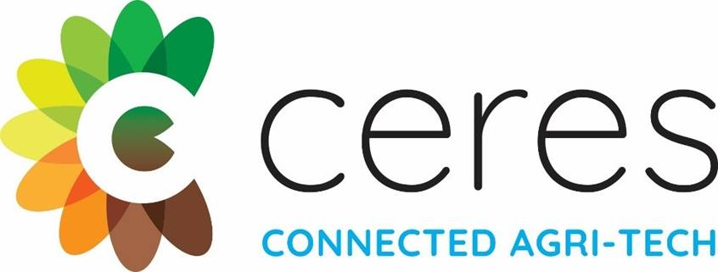

|  |  |  |
| --- | --- | --- |
| |  |  | | --- | --- | | |  | | --- | | We’re pleased to announce the University’s first project to receive investment funding from Ceres. Paul Hadley (APD) and Fred Davis (Chemistry), in partnership with Simon Pearson at the University of Lincoln, have been awarded funding to deliver an innovative project to develop novel plastic film cladding materials for horticultural poly-tunnels. | | |

|  |  |
| --- | --- |
| |  | | --- | | [**Read more**](https://research.reading.ac.uk/ifnh/2019/05/16/ceres-success/#more-7664) | |