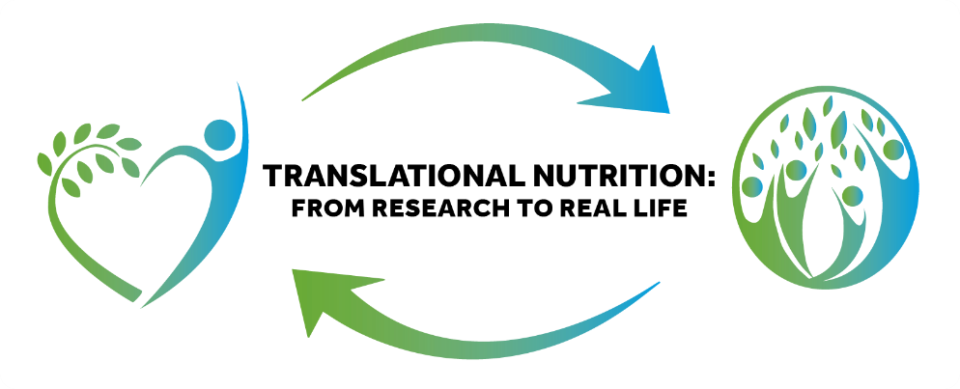

IFNH Anniversary Event 'One Year On' 30 October 2018

IFNH will celebrate its first anniversary with a showcase event, ‘Translational Nutrition: From Research to Real Life’, which will take place at the University of Reading on Tuesday 30thOctober 2018. At this event, University colleagues and valued partners will review how innovative research is responding to key challenges in the areas of nutrition and health.

Read more

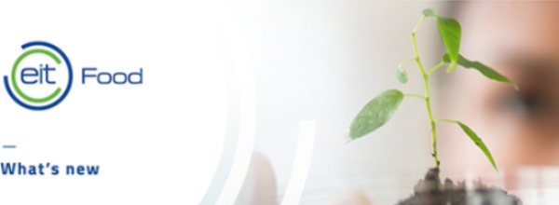
EIT Food Call for Proposals 2019
Colleagues from across the University contributed to the second EIT Food Call for Proposals, for projects to be delivered in 2019. Over 30 final proposals involving the University were submitted in June, of which 16 have been evaluated as high priority for inclusion in the EIT Food Business Plan 2019.

Read more

IFNH at the Berkshire Show 2018

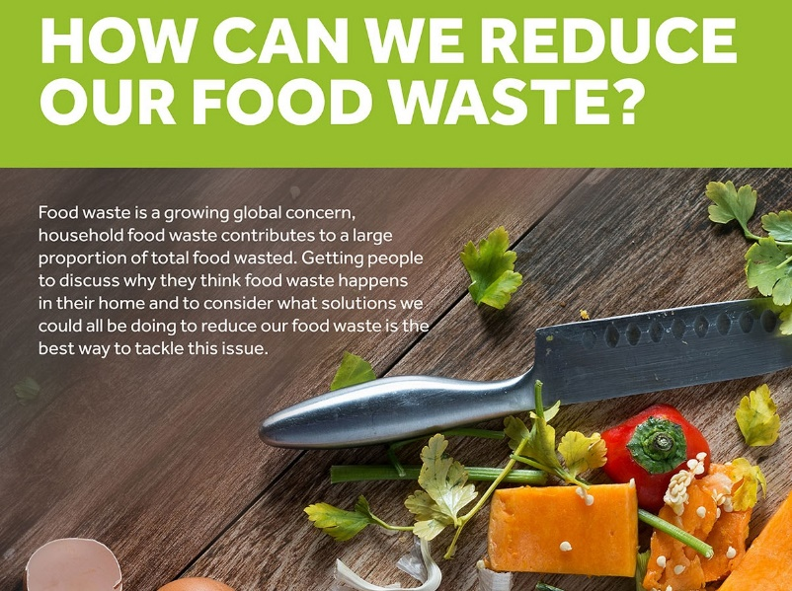
Read more
“What’s in your basket?” was the theme of The University of Reading's exhibit at this year's Berkshire Show. It gave visitors a closer look at several aspects of agriculture and food, with the IFNH running a stand themed around food waste and the ways we can all do our bit to tackle the issue.

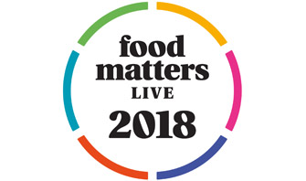
The University of Reading will be at Food Matter Live this November
Food Matters Live will take place at ExCel London from the 20-22nd of November. The exhibition brings together leading food, drink and nutrition industry professionals with a wide range of expertise under the same roof. It attracts thousands of visitors from across the sector, encouraging innovation and collaborative thinking.
Read more

