PRESSBOOK

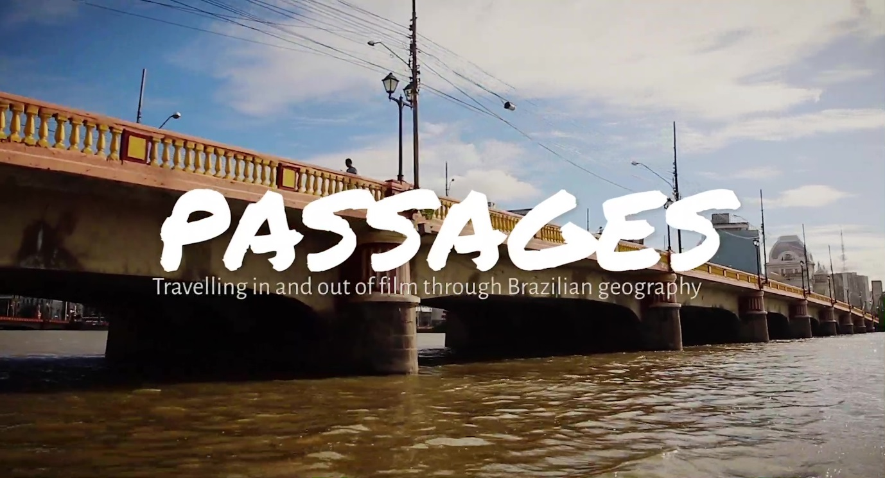

PASSAGES
Travelling in and out of film through Brazilian geography
https://research.reading.ac.uk/intermidia/passages/

Directed by Lúcia Nagib and Samuel Paiva

Based on an essay by Lúcia Nagib
Edited by Tatiana Germano, edt

Synopsis

Positioning itself between the essay and the documentary forms, the feature-length film Passages showcases a selection of Brazilian films in which intermedial devices, that is, the utilisation within film of artforms and media such as literature, painting, theatre, music, photography, radio and television, appear to function as a ‘passage’ to political and social reality. It interweaves these filmic examples with interviews with 15 exponents of the Brazilian film industry, including 11 filmmakers, one editor, one music composer, one producer and one curator, all of whom are strongly connected with what became known as the Retomada do Cinema Brasileiro, or the Brazilian Film Revival, starting in the mid-1990s, which brought back to the agenda the question of national identity and Brazil’s lingering social issues. The flourishing and diversification of independent filmmaking from the 1990s onwards favoured not only a new approach to reality, but also an emboldened use of the film medium that acknowledged and exposed its inextricable connections with other art and medial forms. Though the 1990s Film Revival involved production centres all over Brazil, Passages focuses on film practitioners from São Paulo and Pernambuco, who established a creative collaboration across the geographic, economic and cultural borders of their respective regions.

*
Interviewees (in alphabetical order)

Tata Amaral – Film director, producer, screenwriter
Hélder Aragão (DJ Dolores) – Composer, film director
Cláudio Assis – Film director, producer
Beto Brant – Film director, producer, screenwriter
Paulo Caldas – Film director, producer, screenwriter
Vânia Debs – Film editor, academic
Ana Farache – Curator, photographer
Lírio Ferreira – Film director, producer, screenwriter
Marcelo Gomes – Film director, screenwriter
Hilton Lacerda – Film director, screenwriter
Fernando Meirelles – Film director, producer, screenwriter
Kleber Mendonça Filho – Film director, film critic, screenwriter
Renata Pinheiro– Film director, art director, screenwriter
Adelina Pontual – Film director, producer, screenwriter
João Vieira Júnior – Film producer

São Paulo Crew
Camera: Joyce Cury
Assistant Camera: Mauro Silva
Sound: Debora Taño
Producers: Sancler Ebert, Albert Elduque
Camera and Sound (02 Filmes): Tiago Laires, João Pedro Kohn

Recife Crew
Camera: Francisco Baccaro
Assistant Camera: Pedro Coelho
Sound: Xisto Ramos
Producer: Silvia Macedo

Cambridge Crew
Camera and Sound: Hsin Hsieh, Kjetil Muri Skarstein
Producer: Silvia Macedo

Sound editor supervisor, sound design and mixing
Francisco Mazza

Sound editor
Julia Hardecka

Colour grading
Luciano Munhoz

Research
Amanda Mansur Nogueira

Transcription
Debora Taño

English Subtitles
Roderick Steel

Films quoted (in chronological order)

Soneto do desmantelo blue (Cláudio Assis, 1993)
Maracatu, maracatus (Marcelo Gomes, 1995)
Punk rock hardcore (Adelina Pontual, Cláudio Assis and Marcelo Gomes, 1995)
Baile perfumado (Perfumed Ball, Paulo Caldas and Lírio Ferreira, 1996)
Um céu de estrelas (A Starry Sky, Tata Amaral, 1996)
O pedido (The Request, Adelina Pontual, 1999)
O rap do Pequeno Príncipe contra as almas sebosas (The Little Prince's Rap Against the Wicked Souls, Paulo Caldas and Marcelo Luna, 2000)
O invasor (The Trespasser, Beto Brant, 2001)
Amarelo manga (Mango Yellow, Cláudio Assis, 2002)
Cidade de Deus (City of God, Fernando Meirelles and Kátia Lund, 2002)
Cinema, aspirinas e urubus (Cinema, Aspirins and Vultures, Marcelo Gomes, 2005)
O mundo é uma cabeça (The World Is a Head, Bidu Queiroz and Cláudio Barroso, 2005)
Crime delicado (Delicate Crime, Beto Brant, 2005)
Árido movie (Lírio Ferreira, 2005)
Antônia (Tata Amaral, 2006)
Eu vou de volta (Cláudio Assis and Camilo Cavalcante, 2007)
Blindness (Ensaio sobre a cegueira, Fernando Meirelles, 2008)
Viajo porque preciso, volto porque te amo (I travel because I have to, I come back because I love you, Karim Aïnouz and Marcelo Gomes, 2009)
Febre do rato (Rat Fever, Cláudio Assis, 2011)
Praça Walt Disney (Walt Disney Square, Renata Pinheiro and Sérgio Oliveira, 2011)
O retrato (The Portrait, Adelina Pontual, 2012)
O som ao redor (Neighbouring Sounds, Kleber Mendonça Filho, 2012)
Amor, plástico e barulho (Music, Plastic and Noise, Renata Pinheiro, 2013)
Tatuagem (Tatoo, Hilton Lacerda, 2013)
Rio Doce - CDU (Adelina Pontual, 2013)
Trago comigo (Bring It Inside, Tata Amaral, 2016)
Aquarius (Kleber Mendonça Filho, 2016)

Music videos quoted (in chronological order)
Bob (Lírio Ferreira. Music: Otto, 1999)
Volta (Johnny Hooker. Music: Johnny Hooker, 2015)

Music
‘O Enigma Turco’, DJ Dolores & Orchestra Santa Massa, by DJ Dolores and Maciel Salú

Passages was made possible thanks to an award from the Building Outstanding Impact Support Programme (BOISP), University of Reading

Passages is an output of the AHRC-FAPESP funded IntermIdia Project
https://research.reading.ac.uk/intermidia/

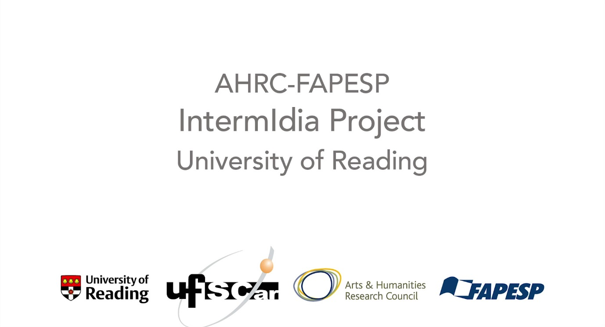

Director Lúcia Nagib

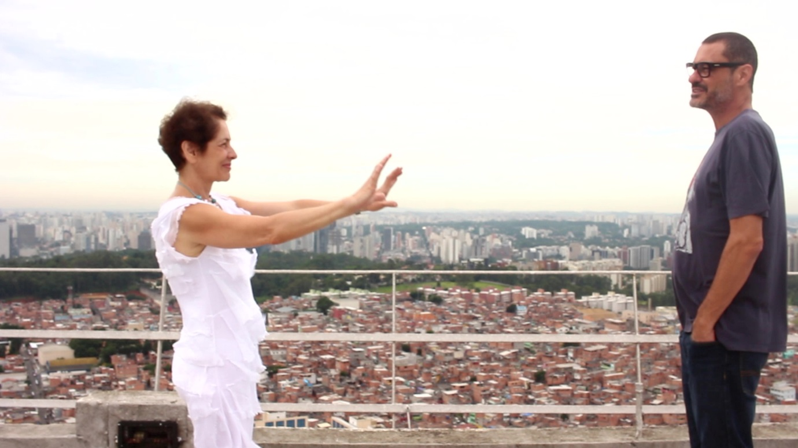

Lúcia Nagib FBA is Professor of Film at the University of Reading and Honorary Professor of Film at the University of Nottingham, Ningbo. She is an internationally recognised specialist in world cinema, cinematic realism and cinematic intermediality, which she has explored through a novel approach in many publications, including her single-authored books, Realist Cinema as World Cinema: Non-cinema, Intermedial Passages, Total Cinema (Amsterdam University Press, 2020) and World Cinema and the Ethics of Realism (Bloomsbury, 2011). Her edited books include The Moving Form of Film: Historicising the Medium Through Other Media (with Stefan Solomon, Oxford University Press, 2023), Towards an Intermedial History of Brazilian Cinema (with Luciana Araújo and Tiago de Luca, Edinburgh University Press, 2022), Impure Cinema: Intermedial and Intercultural Approaches to Film (with Anne Jerslev, I.B. Tauris, 2013), Theorizing World Cinema (with Chris Perriam and Rajinder Dudrah, I.B. Tauris, 2012) and Realism and the Audiovisual Media (with Cecília Mello, Palgrave, 2009). She is the director of feature-length documentary films Passages (with Samuel Paiva, UK, 2019) and Films to Die For (UK, 2025).

Director Samuel Paiva
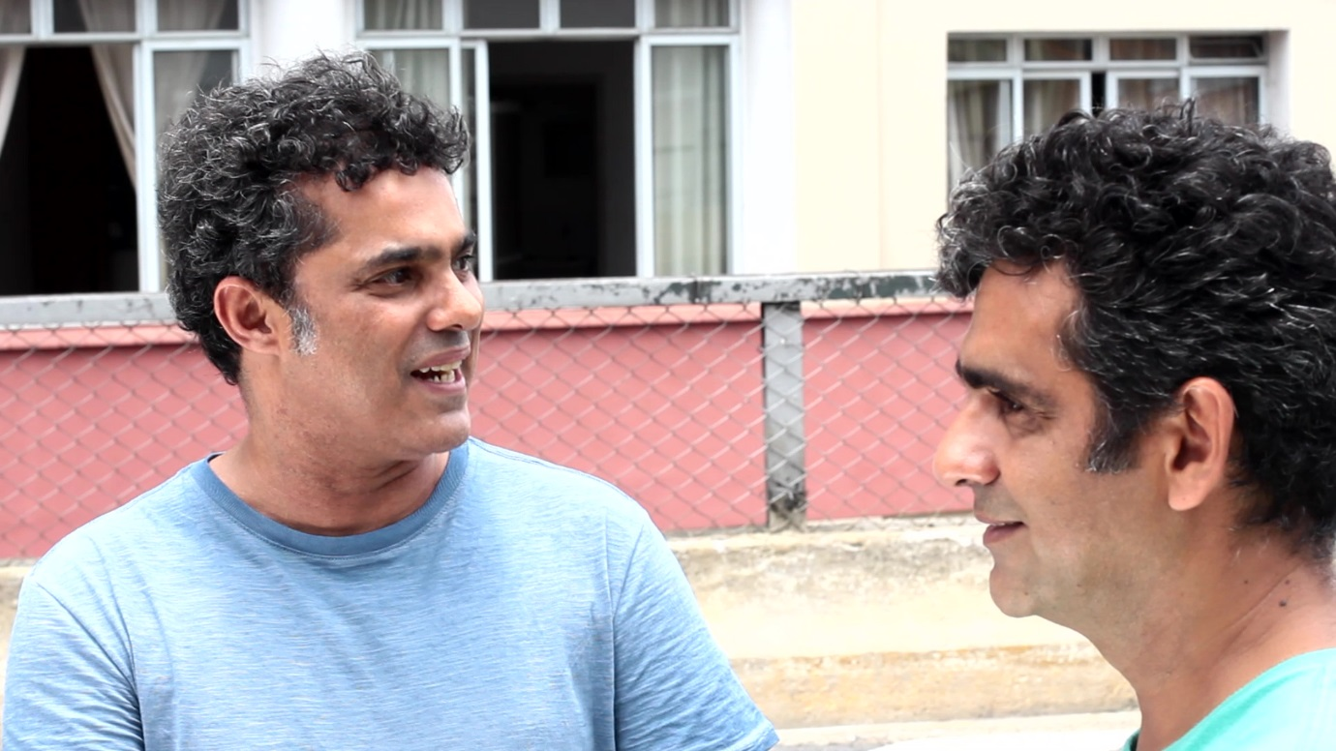

Samuel Paiva is lecturer in Film History in the Department of Arts and Communication, Federal University of São Carlos (UFSCar). Born in Recife, Pernambuco, he has contributed to short films, such as, Morte no Capibaribe (Paulo Caldas, 1983), Henrique, um assassinato politico? (Cláudio Assis, 1986), and the feature film Baile perfumado (Perfumed Ball, Paulo Caldas and Lírio Ferreira, 1996). Between 1999 and 2005 he directed programmes for the São Paulo University TV Channel, targeting audiences beyond academia. Paiva obtained his MA and PhD degrees from the School of Communications and Arts, University of São Paulo, with research on the relationship between cinema and the other arts. His PhD thesis, A figura de Orson Welles no cinema de Rogério Sganzerla, was published in 2018 by Alameda Press. Paiva’s work also includes the co-edited book Viagem ao cinema silencioso do Brasil (2011) and the feature-length documentary film Passages: Travelling In and Out of Film Through Brazilian Geography (co-directed with Lúcia Nagib, 2019).

