Thameside Primary School: Relationships & Sex (RSE) Guidelines
_____________________________________________________

Approved by Governors: April 2019
Review date: April 2022

Thameside Primary School is a Rights Respecting School. School policies will respect the UN Convention on the rights of the child. The guidelines for Relationship & Sex Education (RSE) links to:

Article 24 (health and health services) Every child has the right to the best possible health. Governments must provide good quality health care, clean water, nutritious food, and a clean environment and education on health and well-being so that children can stay healthy.

Article 29 (goals of education) Education must develop every child’s personality, talents and abilities to the full. It must encourage the child’s respect for human rights, as well as respect for their parents, their own and other cultures, and the environment.

Article 34 (sexual exploitation) Governments must protect children from all forms of sexual abuse and exploitation.

Aims
The aims of relationship and sex education (RSE) at our school are to:
- Provide a framework in which sensitive discussions can take place
- Help and support young people through their physical emotional and moral development
- Prepare pupils for puberty, and give them an understanding of sexual development and the importance of health and hygiene
- Help pupils develop feelings of self-respect, confidence and empathy
- Create a positive culture around issues of sexuality and relationships
- Teach pupils the correct vocabulary to describe themselves and their bodies
- Preparing pupils for the opportunities, responsibilities and experiences of adult life.’

Statutory requirements:
These guidelines have been written taking into account the government consultation published in February 2019 regarding the teaching of Relationship Education, Relationships and Sex Education, and Health Education in England. These guideline were then updated in Summer 2020, in preparation for the statutory changes. The Relationships Education, Relationships and Sex Education and Health Education (England) Regulations 2019, made under sections 34 and 35 of the Children and Social Work Act 2017 states that from September 2020, all primary schools must deliver Relationships Education. There continues to be no statutory requirement to teach Relationships and Sex Education (RSE) at a primary level.

Whilst RSE is not compulsory in primary schools, primary schools are required to teach the elements of sex education contained in the science curriculum and the Department for Education continues to recommend that primary schools should have a sex education programme tailored to the age and the physical and emotional maturity of the pupils.

The RSE curriculum at Thameside has been created following guidance issued by the secretary of state as outlined in section 403 of the Education Act 1996.

Definition
RSE is about the emotional, social and cultural development of pupils, and involves learning about relationships, sexual health, sexuality, healthy lifestyles, diversity and personal identity.
RSE involves a combination of sharing information, and exploring issues and values.
RSE is not about the promotion of sexual activity.

It has three main elements:

Attitudes and values

Learning the importance of values and individual conscience and moral considerations;

Learning the value of family life, marriage and stable loving relationships for the nurture of children;

Learning the value of respect love and care;

Exploring, considering and understanding moral dilemmas; and

Developing critical thinking as part of decision making

Personal and social skills

Learning to manage emotions and relationships confidently and sensitively;

Developing self-respect and empathy for others;

Learning to make choices based on an understanding of difference and with an absence of prejudice;

Developing an appreciation of the consequences of choices made;

Managing conflict; and

Learning how to recognise inappropriate behaviour and who to tell

Knowledge and understanding

Learning and understanding physical development at appropriate stages

Understanding basic human reproduction, emotions and relationships

Source: Sex and Relationship Education Guidance DfEE 0116/2000

Moral and Values Framework
Sex education is taught in the context of the school’s aims and values. While sex education in school means that children are given information about sexual behaviour, this is done with due regard to moral and legal considerations and with the explicit values of family life and supportive relationships. In particular, we teach sex education in the belief that:

- sex education is part of a wider social, personal, spiritual and moral education process;
- children should be taught to have respect for their bodies;
- children should be taught to have sensitivity towards the needs and views of others; and to recognise and accept the differences of others;
- children should learn about their responsibilities to others, and be aware of the consequences of sexual activity;
- it is important to build positive relationships involving trust and respect with others;
- children need to learn the importance of self-control and to recognise the physical, emotional and moral implications, and risks of certain types of behaviour;
(Refer to section 2.1 of the 2002 Education Act)

Delivery of RSE
RSE is taught within the personal, social, health and economic (PSCHE) education curriculum. Biological aspects of RSE may also be taught within the science curriculum.

Across all Key Stages, pupils will be supported with developing the following skills:
- Communication, including how to manage changing relationships and emotions
- Recognising and assessing potential risks
- Assertiveness
- Seeking help and support when required
- Informed decision-making
- Self-respect and empathy for others
- Recognising and maximising a healthy lifestyle
- Managing conflict
- Discussion and group work

These skills are taught within the context of family life.

Please also refer to the ‘Teaching and Learning’ policy, the Science policy, the PSCHE and Citizenship policy, Inclusion policy and Equal Opportunities policy.
Children with Special Education Needs or Disabilities (SEND)
It is important for the vast majority of children with SEND to be able to participate in activities and learn alongside their peers and staff will use resources familiar to each child to differentiate work appropriately to ensure equal access to learning. However, for some children, their needs mean that they are at a developmentally different stage to their peers and accessing the same learning may be unsuitable. In these cases, a more developmentally appropriate individual curriculum is created for each pupil, and this is discussed with parents, class staff and the inclusion manager / SENDCo. (please refer to the Inclusion Policy)

Responding to children’s questions
In certain situations, and particularly with older children, teachers may need to broaden discussions depending on the personal situations, misunderstandings and confusions of the children they are teaching. Much of the teaching may be based on unpicking misconceptions. Before starting any of this work it is important to establish ground rules with the children. These rules will be similar to those discussed for circle times. These rules should minimize any embarrassment children might feel and discourage inappropriate personal disclosures. Children should be clear that asking personal questions of the teacher is not appropriate and that teachers may sometimes require time before giving a response.
Teachers should encourage questions and should answer them as openly and honestly as they can. The question asked may be of general interest to the whole class; however, if it requires a response appropriate only to an individual, the teacher should not respond to the whole class but to the individual as appropriate. Where a child is looking for advice the teacher should, wherever possible, encourage them to seek advice from their own parents or guardians and, if appropriate, from relevant health service professionals.
Child Protection Issues
RSE plays a very important part in fulfilling the statutory duties that all schools have to meet (Refer to Keeping Children Safe in Education). RSE helps children to understand the difference between safe and abusive relationships and equips them with the skills to get help if they need it. Any fears or worries they bring into the classroom should not go unnoticed by staff. Teachers need to be aware that effective Relationship and Sex Education, which brings an understanding of what is and is not acceptable in a relationship, can lead to the disclosure of a child protection issue.
If a member of the school’s staff (teaching or non – teaching) suspects that a child is a victim of abuse or they have reason to believe that he/she is at risk of abuse, they should be aware of the procedures for reporting their concerns to the person responsible for child protection. In the case of Thameside Primary School, this is the Headteacher, Mrs Sophie Greenaway or in her absence Mrs Ingrid Burton, Miss Charlotte Rollinson or Miss Christina Calvert. (Please refer to the school safeguarding policy)
Equalities
The Equality Act 2010 covers the way the curriculum is delivered, as schools and other education providers must ensure that issues are taught in a way that does not subject pupils to discrimination. Inclusive RSE will foster good relations between pupils, tackle all types of prejudice and promote understanding and respect.

Roles and responsibilities

The governing board
The governing board will approve the RSE policy, and hold the Headteacher accountable for its implementation.
The Headteacher & the PSCHE leader
The Headteacher alongside the PSCHE leader is responsible for ensuring that RSE is taught consistently across the school, and for managing requests to withdraw pupils from non-statutory/non-science components of RSE.
Staff
Staff are responsible for:
- Delivering RSE in a sensitive way
- Modelling positive attitudes to RSE
- Monitoring progress
- Responding to the needs of individual pupils
- Responding appropriately to pupils whose parents wish them to be withdrawn from the non-statutory/non-science components of RSE
- Staff do not have the right to opt out of teaching RSE. Staff who have concerns about teaching RSE are encouraged to discuss this with the Headteacher or PSCHE leader.
Pupils
- Pupils are expected to engage fully in RSE and, when discussing issues related to RSE, treat others with respect and sensitivity.

The role of parents

The school is well aware that the primary role in children’s sex education lies with parents and carers. This is done through building a positive and supporting relationship with the parents of children at the school through mutual understanding, trust and co-operation.
In promoting this objective we:
- inform parents about the school’s sex education policy and practice;
- answer any questions that parents may have about the sex education of their child;
- take seriously any issue that parents raise with teachers or governors about this policy or the arrangements for sex education in the school;
- encourage parents to be involved in reviewing the school policy and making modifications to it as necessary;
- inform parents about the resources used with regard to sex education (see appendix 1)

Although there is likely to be a range of attitudes towards relationship and sex education across the local community, the school aims to reflect the key messages that parents and carers give to children at home. This can only be done through mutual exchange of knowledge and information. Children benefit from being given consistent messages about their changing body and their increasing responsibilities.
Parents will be informed about RSE lessons in the summer term. They will be given an opportunity to view animations used in school and information on what is to be taught will be sent home.
Parents were consulted on this policy in January 2019. Their views have helped to formulate the aims and objectives and we are very grateful for their interest and involvement. We also take parents views from the annual RSE information meeting into account.
Parents’ right to withdrawWhilst it is compulsory for children to participate in the science components of RSE, for example in Year 2 children are taught about the growth in animals and in Year 5 they should learn about the changes experienced during puberty, parents have the right to withdraw their children from the non-statutory components of RSE. This does not include content set out by the Department for Education for teaching in Relationships Education and Health Education. Please refer to appendix 2 for a full list of content which we have a statutory requirement to teach, for which your child(ren) cannot be withdrawn from.
Requests for withdrawal should be put in writing and addressed to the headteacher. A copy of withdrawal requests will be placed in the pupil’s educational record. A member of the senior management team will discuss the request with parents and take appropriate action.
Alternative work will be given to pupils who are withdrawn from RSE.

Training
Staff training about RSE is included in our continuing professional development calendar. With support from the deputy Headteacher the PSCHE leader will ensure staff new to the school are familiar with the RSE policy and the content they are to teach for their particular year group.
The Headteacher may also invite visitors from outside the school, such as school nurses or sexual health professionals, to provide support and training to staff teaching SRE.

Monitoring arrangements
The delivery of RSE is monitored by the PSCHE leader through:
- lesson observation and feedback given to teachers as laid down in the Thameside monitoring guidelines (please refer to Marking and Feedback guidelines)
- planning will be monitored regularly at team meetings and also at Senior Management meetings
- Learning will be monitored through teacher assessment and through pupil voice interviews.
- Pupils’ development in RSE is monitored by class teachers as part of our internal assessment systems.

Development of the guidelines

These guidelines have been developed in consultation with staff, pupils and parents. The consultation and policy development process involved the following steps:
- Review – the PSCHE lead and Deputy Headteacher pulled together all relevant information including relevant national and local guidance
- Parent/stakeholder consultation – parents and any interested parties were invited to complete a survey related to the teaching of RSE
- Staff consultation – school staff were given the opportunity to look at the policy and make recommendations
- Pupil consultation – we investigated what exactly pupils want from their RSE
- Ratification – once amendments were made, the policy was shared with governors and ratified

L England & I Burton

Appendix 1: Information sheets for parents
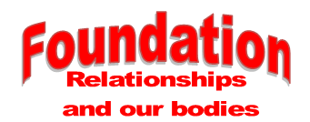

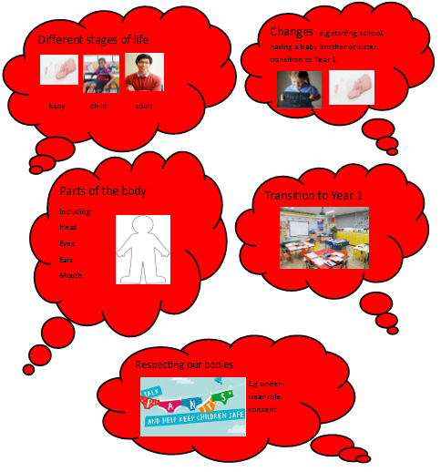
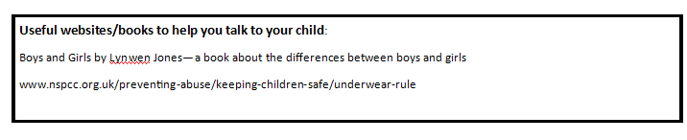
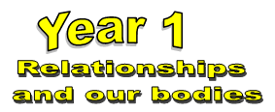

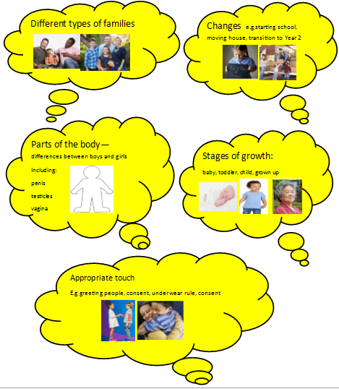
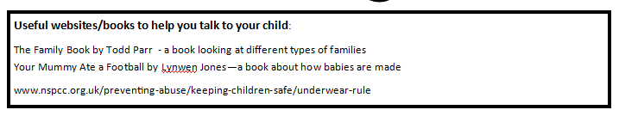

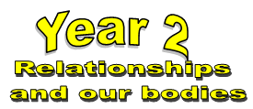

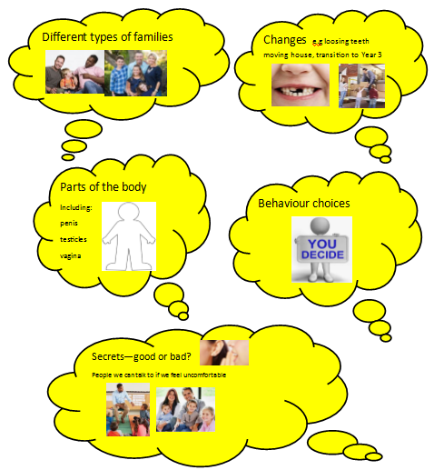

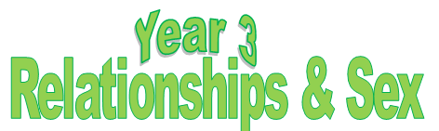
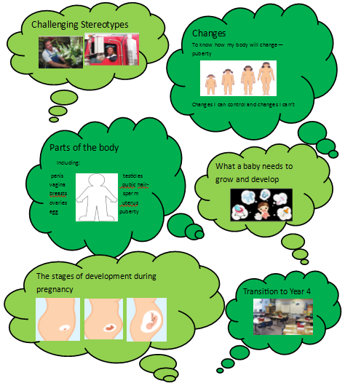

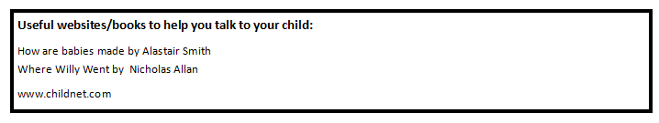

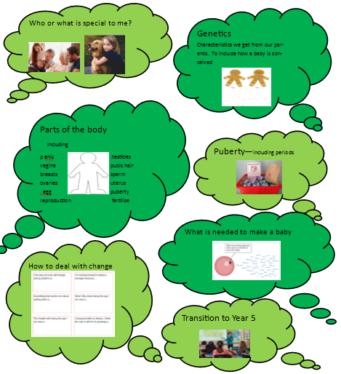
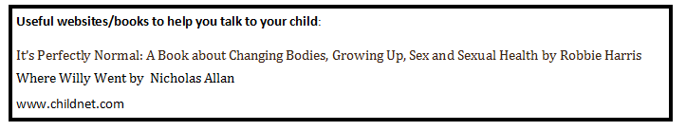

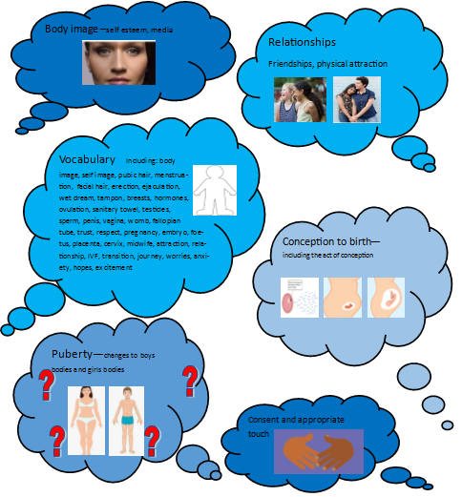
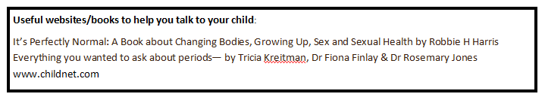

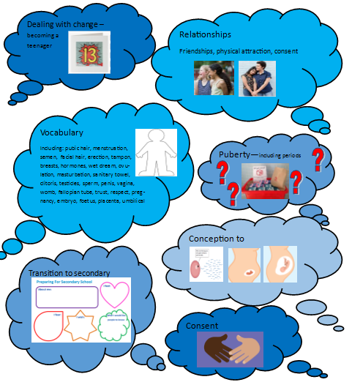
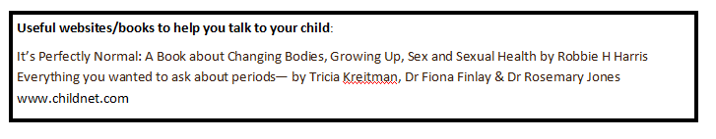

Appendix 2: Statutory Requirements for Relationship Education and Health Education – Source: https://www.gov.uk/government/publications/relationships-education-relationships-and-sex-education-rse-and-health-education/relationships-education-primary#by-the-end-of-primary
Mental wellbeing | that mental wellbeing is a normal part of daily life, in the same way as physical health.
 | that there is a normal range of emotions (e.g. happiness, sadness, anger, fear, surprise, nervousness) and scale of emotions that all humans experience in relation to different experiences and situations.
 | how to recognise and talk about their emotions, including having a varied vocabulary of words to use when talking about their own and others’ feelings.
 | how to judge whether what they are feeling and how they are behaving is appropriate and proportionate.
 | the benefits of physical exercise, time outdoors, community participation, voluntary and service-based activity on mental wellbeing and happiness.
 | simple self-care techniques, including the importance of rest, time spent with friends and family and the benefits of hobbies and interests.
 | isolation and loneliness can affect children and that it is very important for children to discuss their feelings with an adult and seek support.
 | that bullying (including cyberbullying) has a negative and often lasting impact on mental wellbeing.
 | where and how to seek support (including recognising the triggers for seeking support), including whom in school they should speak to if they are worried about their own or someone else’s mental wellbeing or ability to control their emotions (including issues arising online).
 | it is common for people to experience mental ill health. For many people who do, the problems can be resolved if the right support is made available, especially if accessed early enough.
Internet safety and harms | that for most people the internet is an integral part of life and has many benefits.
 | about the benefits of rationing time spent online, the risks of excessive time spent on electronic devices and the impact of positive and negative content online on their own and others’ mental and physical wellbeing.
 | how to consider the effect of their online actions on others and know how to recognise and display respectful behaviour online and the importance of keeping personal information private.
 | why social media, some computer games and online gaming, for example, are age restricted.
 | that the internet can also be a negative place where online abuse, trolling, bullying and harassment can take place, which can have a negative impact on mental health.
 | how to be a discerning consumer of information online including understanding that information, including that from search engines, is ranked, selected and targeted.
 | where and how to report concerns and get support with issues online.
Physical health and fitness | the characteristics and mental and physical benefits of an active lifestyle.
 | the importance of building regular exercise into daily and weekly routines and how to achieve this; for example walking or cycling to school, a daily active mile or other forms of regular, vigorous exercise.
 | the risks associated with an inactive lifestyle (including obesity).
 | how and when to seek support including which adults to speak to in school if they are worried about their health.
Healthy eating | what constitutes a healthy diet (including understanding calories and other nutritional content).
 | the principles of planning and preparing a range of healthy meals.
 | the characteristics of a poor diet and risks associated with unhealthy eating (including, for example, obesity and tooth decay) and other behaviours (e.g. the impact of alcohol on diet or health).
Drugs, alcohol and tobacco | the facts about legal and illegal harmful substances and associated risks, including smoking, alcohol use and drug-taking.
Health and prevention | how to recognise early signs of physical illness, such as weight loss, or unexplained changes to the body.
 | about safe and unsafe exposure to the sun, and how to reduce the risk of sun damage, including skin cancer.
 | the importance of sufficient good quality sleep for good health and that a lack of sleep can affect weight, mood and ability to learn.
 | about dental health and the benefits of good oral hygiene and dental flossing, including regular check-ups at the dentist.
 | about personal hygiene and germs including bacteria, viruses, how they are spread and treated, and the importance of handwashing.
 | the facts and science relating to allergies, immunisation and vaccination.
Basic first aid | how to make a clear and efficient call to emergency services if necessary.
 | concepts of basic first-aid, for example dealing with common injuries, including head injuries.
Changing adolescent body | key facts about puberty and the changing adolescent body, particularly from age 9 through to age 11, including physical and emotional changes.
 | about menstrual wellbeing including the key facts about the menstrual cycle.
Families and people who care for me | that families are important for children growing up because they can give love, security and stability.
 | the characteristics of healthy family life, commitment to each other, including in times of difficulty, protection and care for children and other family members, the importance of spending time together and sharing each other’s lives.
 | that others’ families, either in school or in the wider world, sometimes look different from their family, but that they should respect those differences and know that other children’s families are also characterised by love and care.
 | that stable, caring relationships, which may be of different types, are at the heart of happy families, and are important for children’s security as they grow up.
 | that marriage represents a formal and legally recognised commitment of two people to each other which is intended to be lifelong. (Marriage in England and Wales is available to both opposite sex and same sex couples. The Marriage (Same Sex Couples) Act 2013 extended marriage to same sex couples in England and Wales. The ceremony through which a couple get married may be civil or religious.)
 | how to recognise if family relationships are making them feel unhappy or unsafe, and how to seek help or advice from others if needed.
Caring friendships | how important friendships are in making us feel happy and secure, and how people choose and make friends.
 | the characteristics of friendships, including mutual respect, truthfulness, trustworthiness, loyalty, kindness, generosity, trust, sharing interests and experiences and support with problems and difficulties.
 | that healthy friendships are positive and welcoming towards others, and do not make others feel lonely or excluded.
 | that most friendships have ups and downs, and that these can often be worked through so that the friendship is repaired or even strengthened, and that resorting to violence is never right.
 | how to recognise who to trust and who not to trust, how to judge when a friendship is making them feel unhappy or uncomfortable, managing conflict, how to manage these situations and how to seek help or advice from others, if needed.
Respectful relationships | the importance of respecting others, even when they are very different from them (for example, physically, in character, personality or backgrounds), or make different choices or have different preferences or beliefs.
 | practical steps they can take in a range of different contexts to improve or support respectful relationships.
 | the conventions of courtesy and manners.
 | the importance of self-respect and how this links to their own happiness.
 | that in school and in wider society they can expect to be treated with respect by others, and that in turn they should show due respect to others, including those in positions of authority.
 | about different types of bullying (including cyberbullying), the impact of bullying, responsibilities of bystanders (primarily reporting bullying to an adult) and how to get help.
 | what a stereotype is, and how stereotypes can be unfair, negative or destructive.
 | the importance of permission-seeking and giving in relationships with friends, peers and adults.
Online relationships | that people sometimes behave differently online, including by pretending to be someone they are not.
 | that the same principles apply to online relationships as to face-to-face relationships, including the importance of respect for others online including when we are anonymous.
 | the rules and principles for keeping safe online, how to recognise risks, harmful content and contact, and how to report them.
 | how to critically consider their online friendships and sources of information including awareness of the risks associated with people they have never met.
 | how information and data is shared and used online.
Being safe | what sorts of boundaries are appropriate in friendships with peers and others (including in a digital context).
 | about the concept of privacy and the implications of it for both children and adults; including that it is not always right to keep secrets if they relate to being safe.
 | that each person’s body belongs to them, and the differences between appropriate and inappropriate or unsafe physical, and other, contact.
 | how to respond safely and appropriately to adults they may encounter (in all contexts, including online) whom they do not know.
 | how to recognise and report feelings of being unsafe or feeling bad about any adult.
 | how to ask for advice or help for themselves or others, and to keep trying until they are heard.
 | how to report concerns or abuse, and the vocabulary and confidence needed to do so.
 | where to get advice e.g. family, school and/or other sources.

Suggested Amendment:
The school has a legal responsibility to teach LGBTQ+ content at a timely point. This is delivered at a level that is age appropriate but aims to usualise LGBTQ+ identities, avoiding isolated one off events. Visible diversity and integration of LGBTQ+ topics within our PSCHE curriculum will support this.

