Thameside Primary School: Uniform Policy
_____________________________________________________

Approved by Governors: June 2022
Review date: June 2023

Contents
- Aims | p.3
- Our school’s legal duties under the Equality Act 2010 | p.3
- Limiting the cost of school uniform | p.3/4
- Expectations for school uniform | p.4-7
- Expectations for our school community | p.7
- Monitoring arrangements | p.7/8
- Links to other policies | p.8

Policy reviewed by: | Christina Calvert & Sophie Roseaman
Key Changes: | New Policy

1. Aims
This policy aims to:
Set out our approach to requiring a uniform that is of reasonable cost and offers the best value for money for parents and carers
Explain how we will avoid discrimination in line with our legal duties under the Equality Act 2010
Clarify our expectations for school uniform

2. Our school’s legal duties under the Equality Act 2010
The Equality Act 2010 prohibits discrimination against an individual based on the protected characteristics, which include sex, race, religion or belief, and gender reassignment.
To avoid discrimination, our school will:
- Avoid listing uniform items based on sex, to give all pupils the opportunity to wear the uniform they feel most comfortable in
- Make sure that our uniform costs the same for all pupils
- Allow all pupils to have long hair (though we reserve the right to ask for this to be tied back)
- Allow all pupils to style their hair in the way that is appropriate for school yet makes them feel most comfortable
- Allow pupils to wear headscarves and other religious or cultural symbols
- Allow for adaptations to our policy on the grounds of equality by asking pupils or their parents to get in touch with the Headteacher who can answer questions about the policy and respond to any requests

3. Limiting the cost of school uniform
Our school has a duty to make sure that the uniform we require is affordable, in line with statutory guidance from the Department for Education on the cost of school uniform.
We understand that items with distinctive characteristics (such as branded items, or items that have to have a school logo or a unique fabric/colour/design) cannot be purchased from a wide range of retailers and that requiring many such items limits parents’ ability to ‘shop around’ for a low price.
We will make sure our uniform:
- Is available at a reasonable cost
- Provides the best value for money for parents/carers

We will do this by:
- Carefully considering whether any items with distinctive characteristics are necessary
- Limiting any items with distinctive characteristics where possible
- Considering cheaper alternatives to school-branded items, such as logos that can be ironed on, as long as this doesn’t compromise quality and durability
- Avoiding specific requirements for items pupils could wear on non-school days, such as coats and bags
- Keeping the number of optional branded items to a minimum, so that the school’s uniform can act as a social leveler
- Avoiding different uniform requirements for different year groups
- Avoiding different uniform requirements for extra-curricular activities
- Making sure that arrangements are in place for parents to acquire second-hand uniform items
- Avoiding frequent changes to uniform specifications and minimising the financial impact on parents of any changes
- Consulting with parents and pupils on any proposed significant changes to the uniform policy and carefully considering any complaints about the policy

4. Expectations for school uniform
4.1 Our school’s uniform
Maroon sweatshirt or cardigan (with or without school logo)
Maroon school fleece
White polo shirt
Grey school trousers, shorts, skirts or pinafore dresses
Grey tights or plain white/black/grey socks
Summer dress – maroon or dark red check patterned dress
Black sturdy shoes, black trainers (without logo, stripes or different coloured laces) may be worn

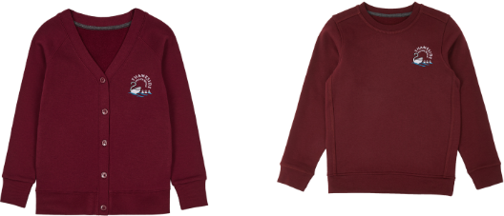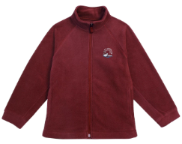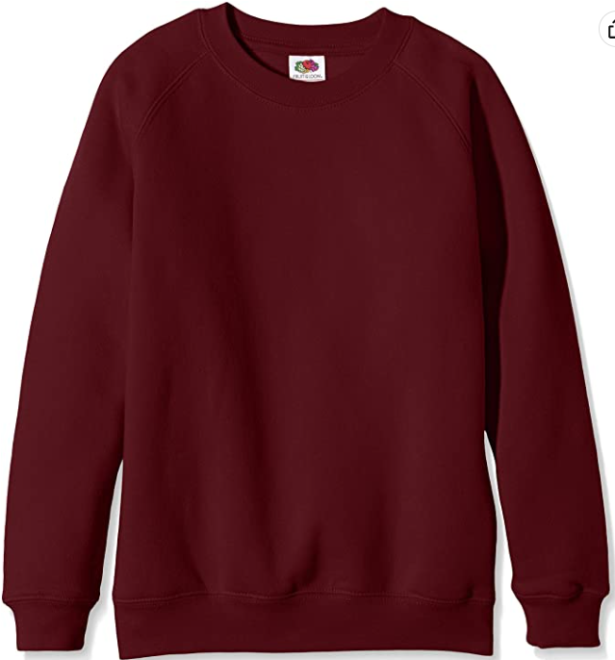
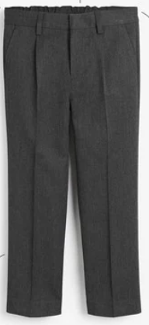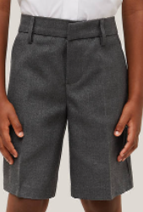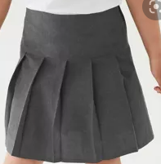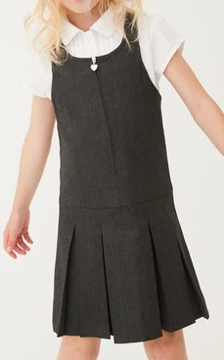
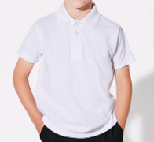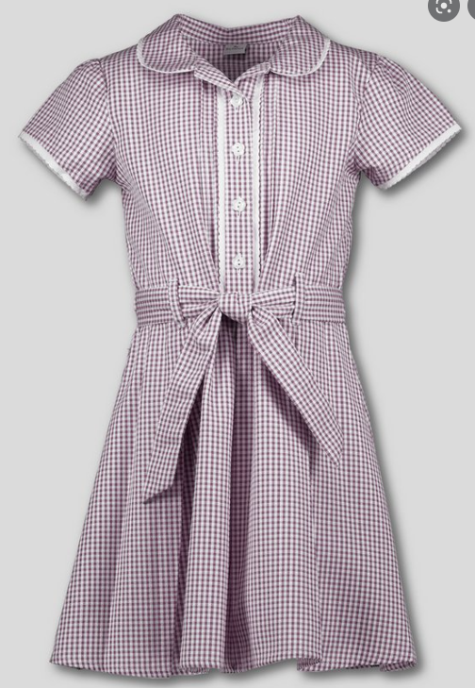
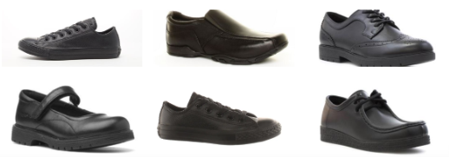

PE Kit
Children will wear their PE kit to school on PE days except for Year 5&6 who will need to bring their PE kit to change into:
White T-shirt
Black shorts (not cycling)
Plimsoles or sports trainers
Plain black tracksuit bottoms
Plain black sweatshirt, school maroon sweatshirt or cardigan (with or without school logo) or maroon school fleece

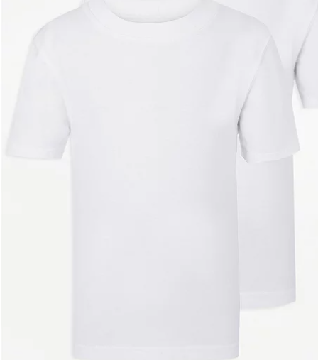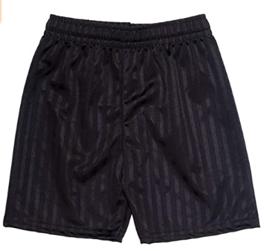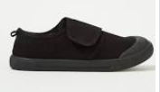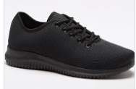
Y6
As a trial for a year children in Y6 may wear a maroon school leavers hoodie in place of the maroon sweatshirt, cardigan or fleece to be ordered through the school office: https://price-buckland.co.uk/ Parents will surveyed at the end of the year for their opinions to see whether this remains as a uniform option in the future.
Jewellery
Jewellery must not be worn in school although small gold or silver studs are permitted. During PE children must either remove stud earrings or, if unable to, cover with tape.
Hair
Hairstyles should be appropriate for school. Shaved patterns are not permitted. Long hair must be tied up as a precaution against the spread of head lice and for PE. Hair bands, ribbons/bows or ‘scrunchies’ should be plain maroon or black to match our uniform. Hair bands should not have large flowers or other decoration attached. Make up and nail varnish should not be worn to school.

Outdoor play and Art
To protect the children’s school uniform when playing in the mud kitchen or participating in art lessons please send in an oversized t-shirt in a plastic bag to remain on their peg.
Please send in named welly boots for children in Reception and Year 1, they can remain in a named plastic bag on their peg.

4.2 Where to purchase it
Items without a school logo can be bought from most high street stores including supermarkets.
School jumpers, cardigans and fleeces with a school logo can be bought from the M&S website: https://www.mandsyourschooluniform.com//m-s-uniform/uniform-by-school/berkshire-oxfordshire/thameside-primary-school/5637146902.c
TSA second hand uniform sales are held regularly
RG4 Uniform group (https://www.facebook.com/RG4UniformGroup) keep a stock of generic and school-specific uniform
Please contact the family hub if you need any support with uniform: familyhub@thameside.reading.sch.uk

5. Expectations for our school community
5.1 Pupils
Pupils are expected to wear the correct uniform at all times (other than specified non-school uniform days) while:
- On the school premises
- Travelling to and from school
- At out-of-school events or on trips that are organised by the school, or where they are representing the school (if required)
Pupils are also expected to contact the Headteacher if they want to request an amendment to the uniform policy in relation to their protected characteristics.
5.2 Parents and carers
Parents and carers are expected to make sure their child has the correct uniform and PE kit, and that every item is:
- Is clearly named
- Clean
- In good condition
5.3 Staff
Staff will closely monitor pupils to make sure they are in correct uniform. They will give any pupils and families breaching the uniform policy the opportunity to comply, but will follow up with the Headteacher if the situation doesn’t improve.
Ongoing breaches of our uniform policy will be dealt with by the Headteacher.
In cases where it is suspected that financial hardship has resulted in a pupil not complying with this uniform policy, staff will take a mindful and considerate approach to resolving the situation.
5.4 Governors
The governing board will review this policy and make sure that it:
- Is appropriate for our school’s context
- Is implemented fairly across the school
- Takes into account the views of parents and pupils
- Offers a uniform that is appropriate, practical and safe for all pupils
The board will also make sure that the school’s uniform supplier arrangements give the highest priority to cost and value for money, for example by avoiding single supplier contracts and by re-tendering contracts at least every 5 years.

6. Monitoring arrangements
This policy will be reviewed at least every two years. At every review, it will be approved by the full governing board.

7. Links to other policies
This policy is linked to our:
- Behaviour policy
- Equality information and objectives statement
- Anti-bullying policy
- Complaints policy

