Pufferfish – a user’s guide for the Department of Meteorology

Authors – Andy Heaps and Roger Brugge
Last updated - 14 March 2017

1. Guide to the equipment
Size of boxes:
- 70 x 70 x 85 (height) cm
- 70 x 97 x 85 (height) cm
- To transport the equipment – use a van.
Parts:
- Large ‘box’ - 1 cable, 1 strap and 2 boxes
- Small box – sphere only
- One laptop, containing VNC software, a web-browser and your images/movies for display. Note that downloading imagery from the internet or a remote host to the Globe is a two stage process – ideally it should be downloaded to the laptop prior to setting up the Globe.

IF YOU ARE TRANSPORTING THE EQUIPMENT FOR USE AT AN EXHIBITION, YOU MIGHT FIND IT BETTER TO TURN TO SECTIONS 8 AND 9 – BUT MAKE USE OF THE FIGURES LISTED ELSEWHERE IN THIS DOCUMENT.

2. Setting up the equipment
Remove the lid of the larger crate – it should look like Figures 1-5.
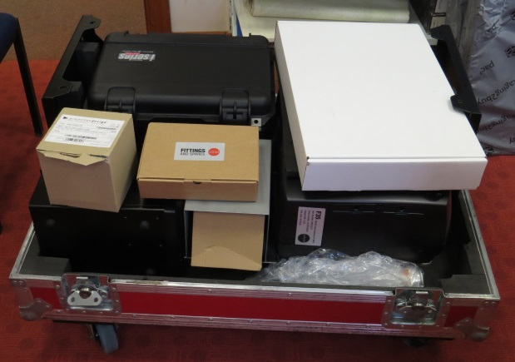
Figure 1. Contents of large crate.
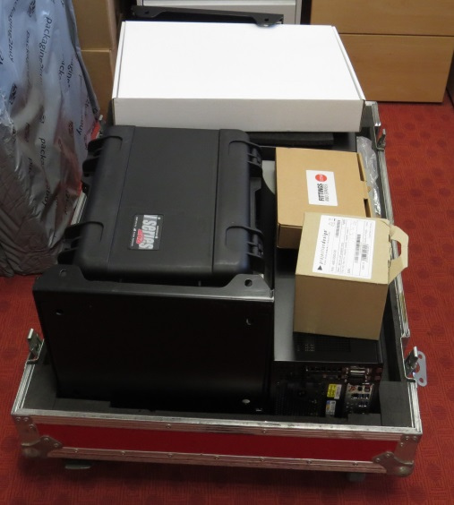
Figure 2. Contents of large crate.
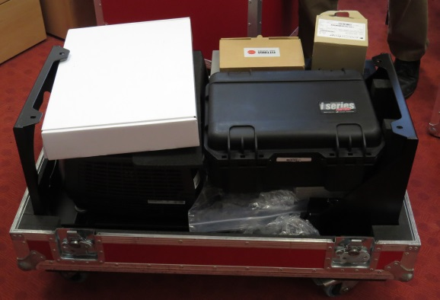
Figure 3. Contents of large crate.
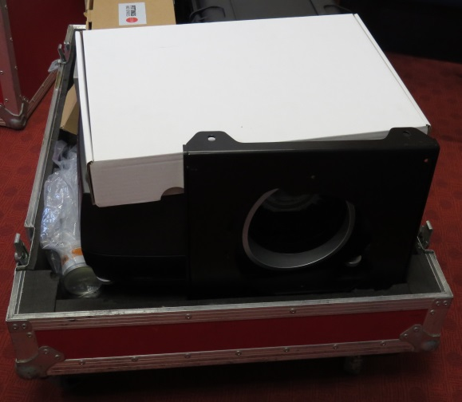
Figure 4. Contents of large crate.
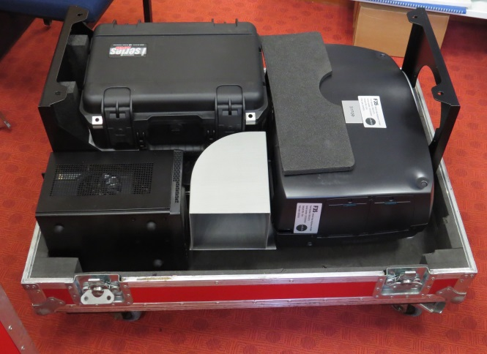
Figure 5. Contents of large crate.

Ordering of kit under projector
- pc
- minimac
- router
- led box [ make sure this is positioned such that the air exiting the fan is directed towards the outside of the base, not inwards towards the other components]
When inserting the lens, lower it vertically into the hole for the lens, inserting the lens such that the two metal silver pins are located either side of the green electronics part shown in Figure 6 – then rotate lens clockwise holding these pins.
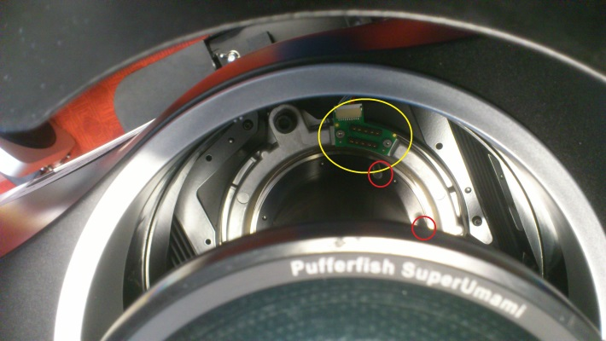
Figure 6. Circled in yellow is the green electronic part mentioned in the text, while circled in red are the two metal silver pins in the locked position after the lens has been rotated clockwise.
Now check that the lens is in focus.

IMPORTANT: You need to connect up all cables except those that go to the globe – then focus the lens by turning the lens so that if focusses onto a sheet of paper close to the lens. Only then do you connect 2 cables to globe and then place globe sphere in place.

3. Obtaining the VNC software
VNC software can be obtained from https://www.realvnc.com/download/viewer/. Only the viewer software is needed- the server version is already installed in the PufferFish computer. If using your own laptop, download the software from this page and install the viewer by running the executable file. A VNC icon should appear on your desktop – if not, it can always be installed using Start/All Programs/RealVNC/VNC viewer. [Click on each of these in turn to launch the viewer – the Start button is the Microsoft Windows button in the taskbar on a Windows7 laptop.]

4. Cable summary:
Cable number and type | Puffer  Console PC | LED driver | Projector | Router | Minimac  vision controller | Interactive ring | Multiway plug socket
Number of cables | 3 | 3 | 3 | 3 | 5 | 2 | 5
P1 – Power | X |  |  |  |  |  | X
P2 – Power |  | X |  |  |  |  | X
P3 - Power |  |  |  | X |  |  | X
P4 - Power |  |  |  |  | X |  | X
P5 - Power |  |  | X |  |  |  | X
A - HDMI | X |  | X
B – Ethernet | X |  |  | X
C – Phoenix cable |  | X |  |  |  | X
D – USB |  | X |  |  | X
E - Ethernet |  |  |  | X | X
F - Firewire800 |  |  |  |  | X | X
G - HDMI |  |  | X |  | X
The two X symbols indicate the connection points of the two ends of each cable. Make sure power cables are securely in place at both ends.

5. Cable diagrams
The Pufferfish should now be ready for use. Hopefully, the cabling looks something like that in Figures 6a-14!

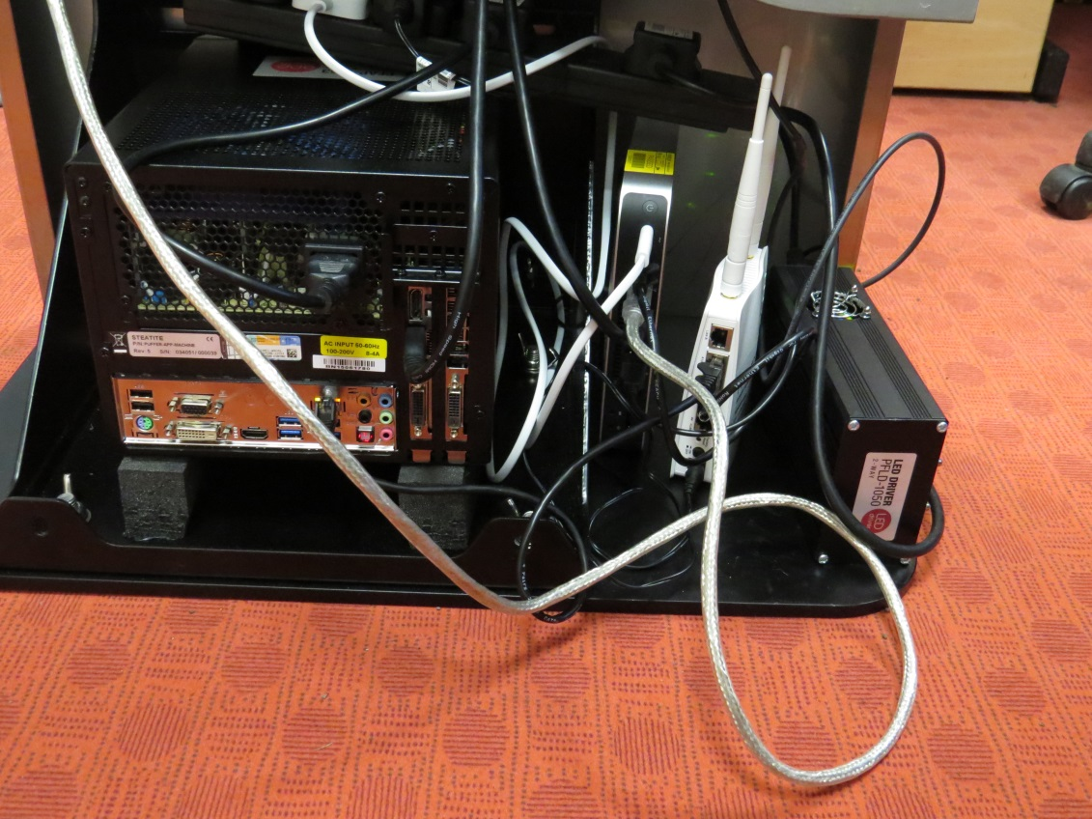
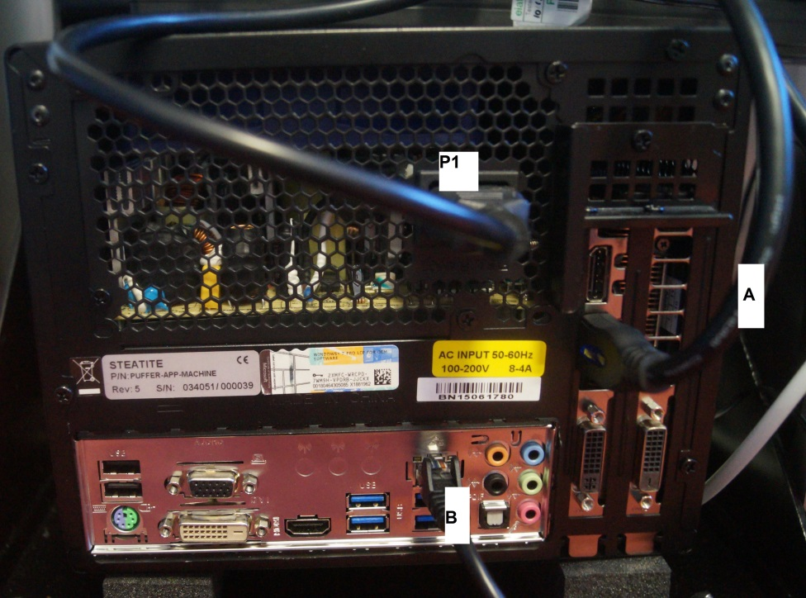
Figure 6a. Cabling installed.
Figure 7. Cabling of the PufferConsole PC. 3 cables:
(top) [Puffer P1] power to multiway plug socket,
(middle/right) [Puffer A] HDMI to projector,
(bottom/left) [Puffer B] Ethernet to the router.

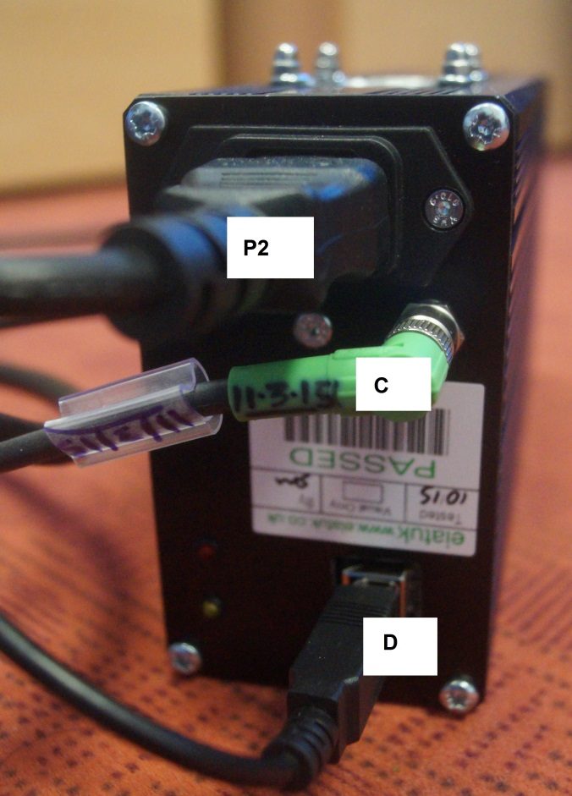
Figure 8. Cabling of the LED driver.3 cables:
[Puffer P2] (top) power to multiway plug socket,
[Puffer C] (middle) phoenix cable to interactive ring below globe,
[Puffer D] (bottom) USB cable to minimac vision controller.

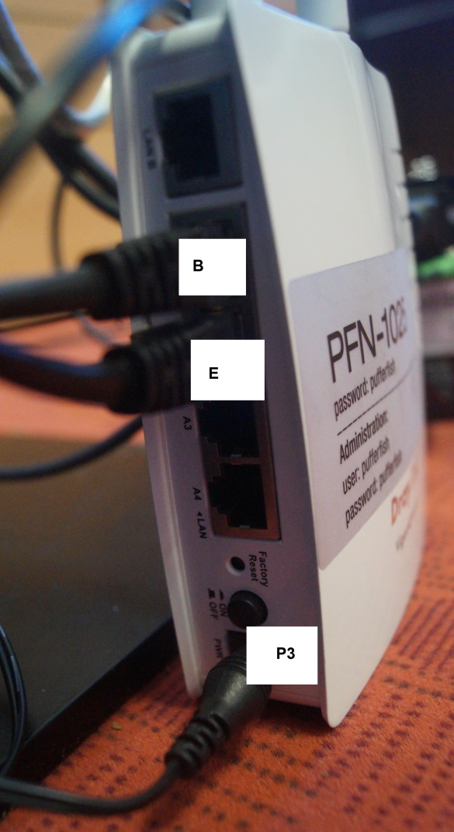
Figure 9. Cabling of the router. 3 cables (and 3 empty sockets).
[PUFFER B] (top) A1PoE socket, Ethernet cable to PufferConsole,
[PUFFER E] (middle) A2 socket, Ethernet cable to minimac vison controller,
[PUFFER P3] (bottom) PWR socket power to multiway plug socket (via a wired-in adaptor)

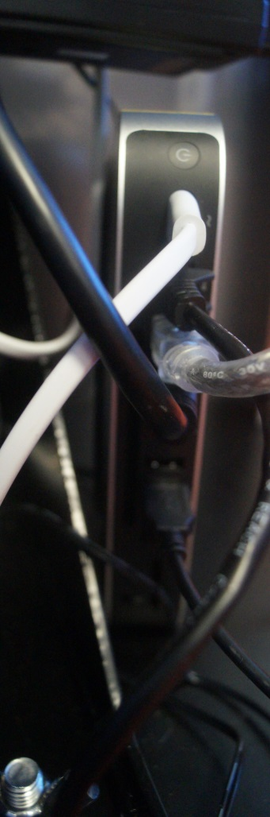
Figure 10. Cabling of the minimac vision controller. 5 cables and 4 empty sockets.
[PUFFER P4] (top) white power cable to multiway plug socket,
[PUFFER E] (socket 2) Ethernet cable to router
[PUFFER F] (socket 3) firewire 800 cable (metal core, plastic sheath) to interactive ring
[PUFFER G ](HDMI socket)HDMI cable to projector
(sockets 5-6) no cables attached
[PUFFER D] (socket 7) USB cable to LED driver

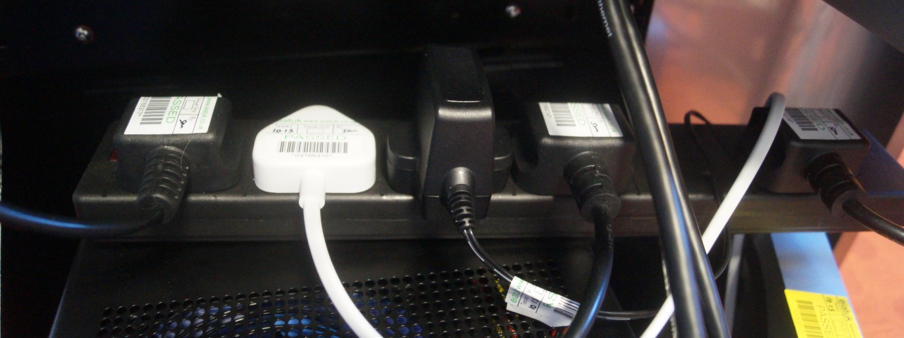
Figure 11. Multiway plug socket, with power cables to (left to right) [PUFFER P5] projector, [POWER P4] minimac vision controller, [POWER P3] router, [Puffer P1] PufferConsole, [Puffer P2] LED driver.

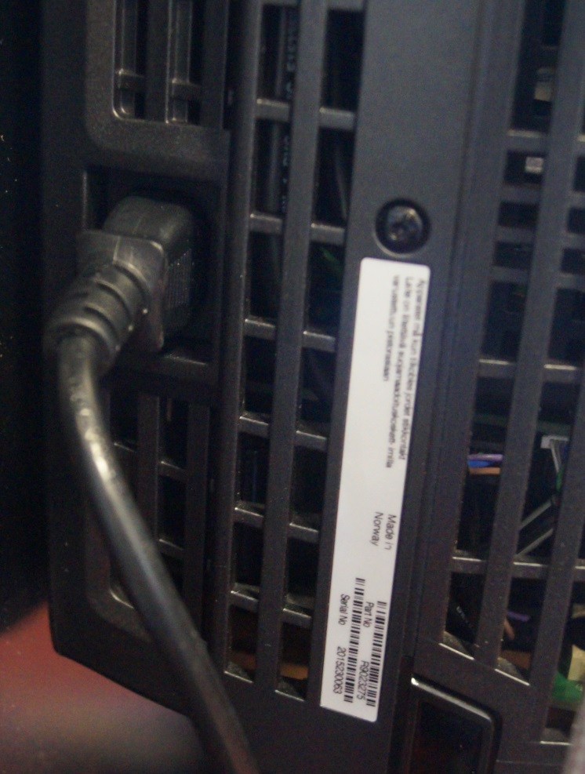
Figure 12. Power connection to projector from multiway plug socket [PUFFER P5].

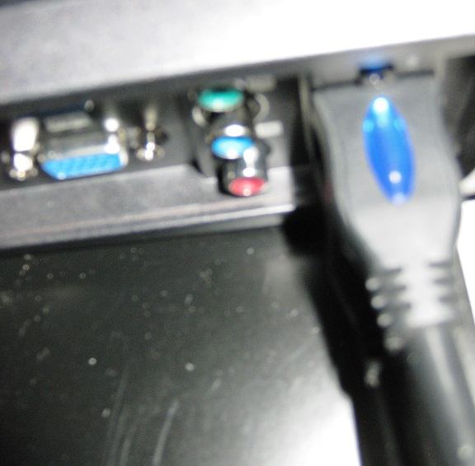
Figure 13. Two HDMI connections from underside of projector to [PUFFER A] PufferConsole (visible in image) and [PUFFER G] minimac vision controller (hidden in image).

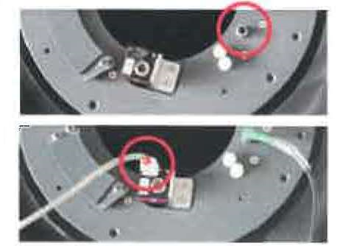
Figure 14. Illustrating the location of the connection point of the Phoenix cable to the interactive screen ring (green-socket cable, circled in upper image) from the LED driver, and of the Firewire 800 cable to the camera (circled in the lower image) from the minimac vision controller.

6. Using the Globe

1 Connect the main plug to the mains
2. Physically turn on the macmini – may be on automatically and make a chiming noise
3. Physically turn on the projector – you should see the 3 yellow lights turn green
4. Connect your laptop to the PFN-1025 network ; you will need to remove any network Ethernet cabling and close any existing connection to a wireless network first. Use the wifi connection software on your PC
5. Turn hand console on – POWER button + OK; BUT CHECK TOP OF THE GLOBE for any message suggesting that you are powering it down BEFORE you press the OK button.
Try skipping 6-8
6. Connect VNC to 192.168.1.30 on your laptop; if a password is required then use ‘pufferfish’
Enter c at the keyboard – the laptop will show a red circle and a moving finger
7. Press HDMI1 on the handheld console and then Ok
=> Nothing appears on the globe…?
Disconnect VNC
Use browser and login to 192.168.1.30 and use Restart
Reconnect VNC, click on recalibration box and type c
Red circle appears on screen and globe
8. Trace out required circles on the screen
Once these have been traced successfully, a screen of settings appears on the laptop and on the globe.
9. Close down VNC and reopen it, connecting to 192.168.1.40 (password is puffer);
Press ESC , scroll down off the bottom of green screen, click on Start/Computer/Local Disk (C:)/PufferConsole/Applications/PufferWarp/PufferWarp.application
10. Use browser and login to 192.168.1.40 (pufferfish and pufferfish are username and password)
11. Make sure that the default application in the brower/PufferConsole is InteractiveGlobe-06-02-15
11. Right mouse click on PufferWarp and open it in a new Tab
12. Press HDMI2 on the handheld console and then Ok – IGNORE this command?
13. Click on one of the images/movies that appears in the browser

To load a new movie or image on to PufferFish:
- Your files must be png, mov or wmv files – we think! Make sure your files are not zipped together.
- Go back to the PufferConsole home window on the browser
- Click on Upload asset files ‘Choose file’button
- Move around your laptop to locate the required image/movie
- The upload it using the Upload button
- Reload the PufferWarp link from the home window on the browser in a new tab (or refresh it)
- Play the new movie by clicking on it
- If necessary, you can rename the file by doing so in Computer\Local Disk (C:)\PufferConsole\assets via the VNC screen (ESC to get a green PC desktop and then scroll down to the start button before locating this directory). You may then need to restart PufferWarp in a new tab in your browser (or at the very least refresh the tab to enable the new filename to be picked up)

Converting image files into a movie – this needs to be done before setting up the globe. You will have no internet connectivity once the globe is in operation.
- Need cylindrical projection with no external annotation – no labelling, titles, colour bars, etc.
- Ideally indicate the time of each frame on the image itself – for many moves a timestamp over the Pacific (or over land for an SST movie) will be most useful.
- Begin by creating a sequence of png files.
- On a unix terminal type:
mkdir temp
convert *.jpg –delay 10 temp/%05d.jpg
ffmpeg –I temp/%05d.jpg output.mp4
- This will create a file called output.mp4

Deleting files from Pufferfish
- Go back to VNC window and click on ESC
- Go to Computer\Local Disk (C:)\PufferConsole\assets
- Locate required file
- Right mouse click on file and delete it to recycle bin
- Return to browser and refresh http://192.168.1.40/PufferWarp - file will be removed from list of those available to view
- Try playing a new movie – if this fails then remove the PufferWarp tab in your browser and restart it in the browser as a new tab

7. Replacing the projector lamp
To be written…

8. Turning off, and packing the equipment away – as per a demonstration to potential users
You will need the complete globe, the remote control, the toolbox and the red containers in which to pack away the equipment.
If the globe is showing any movies, then perform as many of the following that are appropriate; those marked ** may not be necessary if the globe is showing no images and no laptops are in use
- **Go back to PufferConsole home window in the browser
- **Close the web browser
- **Close the VNC connection – move mouse to top of the screen and drag down the toolbar here, closing the connection
- On the hand console, press the power button (a message will appear on top of globe) and then press OK. Lights underneath the projector will flash yellow, then turn yellow.
- The fan will slow down
- **Turn the minimac off; also turn the PufferConsole-PC off – the on/off button is located on the top/front of the PC
- Turn the power off at the mains, and remove the mains plug from its socket in the wall/floor.
- Do not move the lens/projector immediately; wait about 15-30 minutes for the projector to cool down
- **Disconnect laptop from PFN-1025 network.
- Now pack everything away.
- Unscrew the sphere of the globe in an anticlockwise direction from the top of the instrument; unscrew until a ‘clunk’ is heard
- Then, one person holds the sphere and a second person removes the two cables from the interactive ring under the sphere
- Put the sphere in its red container; drape the white sheet in the box across the opening of the box and gently place the sphere on the sheet and into the box; rotate the sphere so that the electronics at its base are pointing into a corner of the box.
- To remove the lens, one person will need to press down on the lens release button (circled in yellow, Figure 15)/Do this by inserting you hand horizontally to make contact with the button. While this button is being held down, a second person should insert their hands down, alongside the lens using the cut-outs (red triangle ‘holes’); hands should be inserted such that your palms are placed around the lens – then grasp the two metal vertical pits with two fingers and rotate the pins anticlockwise). When rotating the body of the lens (at its base) DO NOT ROTATE LENS ITSELF. Place the lens body into the black lens container (the black plastic container – see figure 3); remove the plastic cap from that container and insert it into the ‘hole’ left by the lens in the equipment (as protection).

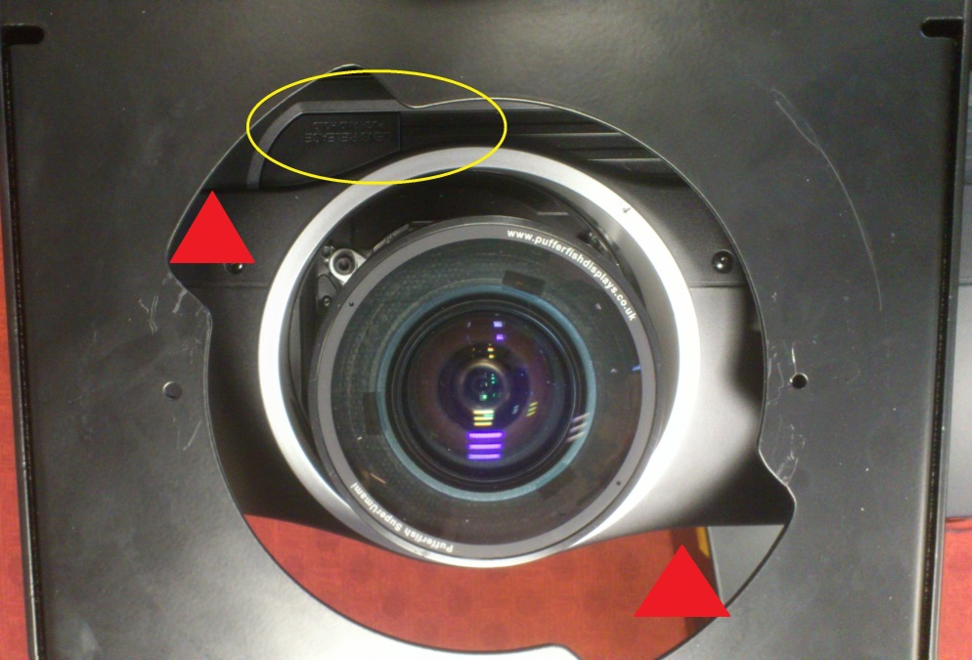
Figure 15 – circled in yellow is the lens release button. When unlocking the lens it might be helpful to insert your hands in the ‘holes’ marked with the red triangles.

- Unscrew the screws from the two side panels (the ones with the grilles) and place them in the corresponding plastic bag in the toolkit
- Lift off the black metal top of the (this goes in the flat red container)
- Remove the side panels (with grilles) – these go into the flat red container
- Undo all the 8 wingnuts on the front and back metal silver plates – two at the top and two at the bottom of each plate - and place them in the corresponding plastic bag in the toolkit
- Remove these two front and back metal silver plates – these go into the flat red container
- Remove all the cables and place them in the A4-size ‘tagged’ cable box
- Remove the 4 ‘computers’ from the base (pc, minimac, router and led box) and place in cardboard boxes (as appropriate ready to place in large crate later)
- Rotate the remaining kit (i.e mainframe) onto its side and remove the four large screws and hence the large black metal baseplate. The latter goes into the flat red container
- Put the remaining kit (the mainframe minus the baseplate) into the third large red container (figure 5) and then place all boxes on the top of this, before securing the lid.
- Do not worry if you cannot pack everything into the containers – as long as whatever is kept out is secure and is protected from damage or scratches.

9. Installing and tuning on the equipment – as per a demonstration to potential users
This is essentially the reverse of the previous section – make sure this work is done IN THE LOCATION WHERE YOU WISH TO USE THE GLOBE
Items marked ** may need to be done if you subsequently believe that the globe lens need to be re-focussed
- Extract the mainframe from its box and place on its side (with the area where the IT equipment will go being uppermost) and connect the large black metal baseplate (the one without the hole) using the large silver screws.
- Tip this mainframe on to its base and place into the final location on the ground where you wish to use the globe
- Place the four IT items on the base (see figure 6a) with the vent of the fan in the LED box facing outwards
- Place the large multiway socket plug on top of these four items
- Insert all the cables – install the power cables first (see cable summary and cable diagrams sections)
- Place the top metal black plate (the one with the hole in it) in place
- Insert the lens into place (removing the plastic cover from inside the kit – and storing it in the lens case)
- When inserting the lens, lower it vertically into the hole for the lens, inserting the lens such that the two metal silver pins are located either side of the green electronics part shown in Figure 6 – then rotate lens clockwise holding these pins.
- Now remove the globe sphere from its container and connect up the two cables to the interactive ring (figure 14) and put globe sphere in place. Make sure that the two cables on the interactive ring remain in places as you turn the sphere clockwise until it ‘clunks’.
- Insert mains plug into the mains and all should start up – the minimac makes as noise as it turns on.
- Check everything is working. If the fan blades on the top of the PC can be seen (left of figure 6a) then you need to turn this on – the on/off switch is at the top /front/left (furthest away from the camera as viewed in figure 6a). This should make a noise when turned on.
- Use the handheld console and press the Power button (aiming it towards the top of where the side grille closest to the PufferConsole PC would be); wait a minute or so and a label should appear on the top of the globe sphere. Hopefully a movie will start to play. You are now ready to proceed.
- ** If the lens is not in focus on the globe sphere when a movie is playing, one person can remove the globe sphere (ensuring no cables drop off) and a second person can then focus the lens by turning the lens so that if focusses onto a sheet of paper held close to the lens. Then reinstall the glove sphere.
- Place the silver metal front and back plates on using the 8 wingnuts – start with the plate further from the cabling. Slot each in bottom-end first and then tilt the top end into place. Do up all the wingnuts finger tight.
- Install two side panels with grilles – again, finger tight and there is no need to use all the screws – just enough to lock the sides soundly and to protect the inner workings. Ensure that the external power cable comes out under the panel closest to the LED, and furtherest from the PufferConsole PC.

10. Getting started
Maria Broadbridge has written a small webpage about the globe at http://www.met.reading.ac.uk/it/home/facilities/globe.php from which the following notes have been extracted.
Instructions on how to interact with the globe
When the globe is switched on and a movie is playing you can explore it by gently sliding your finger across it to change the rotation.
If you want to change the movie that is currently playing or upload your own, you'll need a password for the pufferfish network and the globe's browser interface. You can get these from Maria Broadbridge.
This is how it works:
When you're in the library, you can use any device with wifi capabilities (laptop, tablet, smartphone etc.) to connect to the pufferfish network (PFN-1025).
Open your web browser and type 192.168.1.40 into the address bar, which connects you to the globe's interface called Puffer Console. You can upload a movie from your device by clicking on "Choose File" in the "Upload asset files" field, selecting your movie file and then clicking "Upload".
Click on the PufferWarp link near the top right to open the movie library. You can then select your uploaded movie from the list (or any other movie you wish to play). Refresh the page if your uploaded movie isn't showing yet. Once selected, your movie should start displaying on the globe.
You can adjust the rotation by dragging your finger/mouse pointer across the "Rotation" area below the movie list. Click "Reset rotation" if you want to revert back to the default.
Unfortunately there are no playlist options available in the pufferfish software at the moment so the selected movie will keep playing until a new one is chosen.
Please contact us if:
You require the globe display for a specific event, either within the department or away. In this case, please book it via the globe diary here. If this is the first time you wish to take the globe offsite, please contact Maria Broadbridge in the first instance, as dismantling and transporting the glove is not straightforward you require some training to do it.
Please contact Maria Broadbridge if:
- you require assistance in creating and/or uploading a movie
- the above instructions don't seem to work
- you notice that something appears to be wrong with the globe
Acceptable use policy:
- Please don't delete any movies from the globe interface unless you created them yourself.
- Please don't switch the globe off at the mains.
- Please don't change the timer settings without notifying Maria first.

11. Trouble-shooting
In case of problems, the following might be of use. Please add to the list (either write on the paper copy stored in the red boxes or email me at r.brugge@reading.ac.uk).
- Can’t find the toolkit or hand-held controller: Normally stored in a drawer in the IT support office on level 3 of Meteorology.
- Everything seems to be working – lights on all the computers/routers etc and lights on the underside of the large black display unit are green and not orange – but there is nothing on the screen: Check that there are three lens caps/protectors in the lens box. One of these should have come from the inside of the machine and two from the lens unit (one at either end). If the yellow one (in particular) is not in the lens box you have probably forgotten to remove it. Remove the lens from the globe and check both ends, removing the yellow lens cap.
- The movie is running but the black area close to the south pole is rather large or distorted: Possibly the aspect ratio of the movie has been altered accidentally: On the hand-held controls there is a button marked ‘ASPECT’ – try pressing this and see if the black area at the base of the globe changes shape and reverts to the expected pattern.

