ORDER FORM

“One Hundred Years of Reading Weather”
by Roger Brugge and Stephen Burt

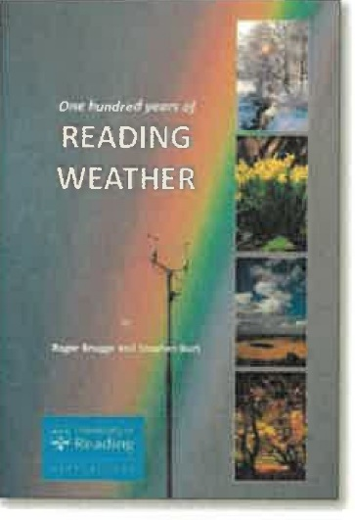

Please send ……. copies of the above book to:

Title: ……. First name: …………………. Surname: ……………………….

Address: ………………………………………………………………………………...

Postcode: ………………

Country: ……………...

The book price is £10:
- Plus £3 for postage & packing for addresses in the UK = £13.
- Plus £7 for postage & packing for addresses in Europe = £17.
- Plus £8 for postage & packing for addresses outside Europe = £18.

I enclose a cheque for £ ……..

Please send this completed order form, with a cheque written in pounds Sterling, made payable to “University of Reading”, to:
Nicki Robinson, Departmental Secretary
University of Reading
Brian Hoskins Building
Whiteknights Road
Earley Gate
Reading
Berks RG6 6ET

