ORDER FORM

“Meteorology at Reading: The First 40 Years”
by Jackie Hoskins

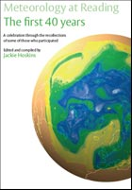

Please send ….. copies of the above book to:

Title: ……….. First Name: ……………………. Surname: ………………..………

Address: ……………………………………………………………………………..……..

Postcode: …..……………….

Country: ……………………

The book price is £5:

- Plus £3 for postage and packaging for addresses within the UK = £8.

- Plus £4 for postage and packaging for addresses outside the UK = £9.

I enclose a cheque for £………..

Please send this completed order from, with your cheque written in Pounds Sterling made payable to “University of Reading”, to:
Nicki Robinson, Departmental Secretary
University of Reading
Brian Hoskins Building
Whiteknights Road
Earley Gate
Reading
Berks RG6 6ET

