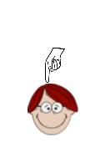
Word Class Actions
NOUN  Put hand above eyes and scan the room. This is because everything you can see is a noun – check by putting ‘a’ or ‘the’ in front of it. The exception is an abstract noun so the additional wording might be ‘everything you can see and feel’.  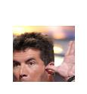 |  | PRONOUN  With your hand in the position for a noun, remove it and point to the top of your head instead. A pronoun replaces a noun.  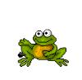
ADJECTIVE  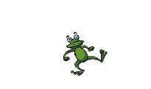  With your hand in the position for a noun, put your other hand next to your head and wiggle it thereby making the noun more interesting. |  | VERB  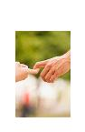  Move your arms to perform an action as if walking.
ADVERB  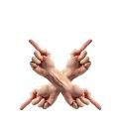  Move your arms and legs wildly, franticly, madly, crazily. |  | CONJUNCTION  Link the first finger of one hand with the first finger of the other hand. Your hands represent the two parts of the sentence to be joined by the conjunction which is your fingers.
PREPOSITION
Hold up your arms crossed in front of your body and point the first finger of each hand so that they are pointing in different directions. This indicates the the position of a noun.

