Vocabulary
A For each question, put a cross (x) under the English meaning that matches what you hear.
You will hear each German word twice. Choose one correct answer only.
 | A | B | C | D
1. | thing | present | notebook | board
 | ☐ | ☐ | ☐ | ☐
2. | I | you | she | he
 | ☐ | ☐ | ☐ | ☐
3. | to understand | to play | to win | to have
 | ☐ | ☐ | ☐ | ☐
4. | human being | friend | dog | woman
 | ☐ | ☐ | ☐ | ☐
5. | wrong | right | red | yellow
 | ☐ | ☐ | ☐ | ☐
6. | very | often | or | but
 | ☐ | ☐ | ☐ | ☐
7. | bag | water | song | word
 | ☐ | ☐ | ☐ | ☐
8. | to be | to think | to do, make | to know
 | ☐ | ☐ | ☐ | ☐

B For each question, put a cross (x) under the type of word you hear.
You will hear each German word twice. Choose one correct answer only.
This word is a good example of …
 | A | B | C | D
1. | a number  ☐ | a place  ☐ | an activity  ☐ | a person  ☐
2. | a colour  ☐ | an animal  ☐ | a question word  ☐ | a greeting  ☐
3. | a person  ☐ | an object  ☐ | a food  ☐ | a place  ☐
4. | an activity  ☐ | a number  ☐ | a colour  ☐ | an animal  ☐

C Translate the underlined German word to complete each English sentence.

1. Auf Wiedersehen Frau Schmidt! ______________ Mrs Schmidt!
2. Ist er da? Is he ______________?
3. Was ist dein Lieblingstier? What is your ______________?
4. Er ist zu Hause. He is ______________.
5. Der Tisch ist sehr klein. The table is ______________ small.
6. Das Bild ist groβ und gelb. The picture is big ______________ yellow.
7. Ich höre Musik. I ______________ music.
8. Wie sagt man ‘German’? ______________ ‘German’?

D For each question, put a cross (x) under the word that best fits each category.
Choose one correct answer only.
This word is a good example of …
 | A | B | C | D
1. a number | rot  ☐ | acht  ☐ | unten  ☐ | wie  ☐
2. a food | Kuchen  ☐ | Frau  ☐ | Punkt  ☐ | Lied  ☐
3. a country | Haus  ☐ | Wasser  ☐ | Fenster  ☐ | Deutschland  ☐
4. an activity | sein  ☐ | spielen  ☐ | haben  ☐ | verstehen  ☐
5. a place | Tafel  ☐ | Nummer  ☐ | Schule  ☐ | Herr  ☐

E Translate the underlined English words to complete the German sentence.
1. Yes, I am here. ________, ich ________ hier. (Write two words.)
2. Here is the dog. Hier ist der ________. (Write one word.)
3. There are four things. ____________ vier Dinge. (Write two words.)
4. Max sings. Max ________. (Write one word.)
5. Jakob has ten flowers. Jakob hat ________ Blumen. (Write one word.)
6. Where is my book? Wo ist mein ________? (Write one word.)
7. I think. Ich ________. (Write one word.)
8. The example is false. Das Beispiel ist ________. (Write one word.)
9. How’s it going? Not so good! Wie geht’s? Nicht so ________. (Write one word.)
10. You have the game. Du hast das ________. (Write one word.)

Total marks available (Vocabulary): 44
Grammar
A Put a (X) next to the person the sentence is about.

1 | ☐ I  ☐ you _{[singular]}  ☐ she/he | … habe das Foto.
2 | ☐ I  ☐ you _{[singular]}  ☐ she/he | … lernst viel.
3 | ☐ I  ☐ you _{[singular]}  ☐ she/he | … bist toll.
4 | ☐ I  ☐ you _{[singular]}  ☐ she/he | … spiele Fußball.
5 | ☐ I  ☐ you _{[singular]}  ☐ she/he | … ist in Deutschland.

B Add a full stop (.) or a question mark (?) next to each sentence to show whether it is a statement or a question.

1. Hört sie Musik

2. Du singst ein Lied

C Put a (X) next to the English meaning of the German sentence.
1 | Das Buch ist nicht klar. | ☐ The book is clear.  ☐ The book is not clear.
2 | Du hast keinen Fuβball. | ☐ You have a football.  ☐ You don’t have a football.
3 | Das ist ein Bleistift. | ☐ That is a pencil.  ☐ That is not a pencil.

D Write the German word for ‘a’ in the gap.
1 | ________ Blume (f)
2 | Sie hat ________ Tisch. (m) | 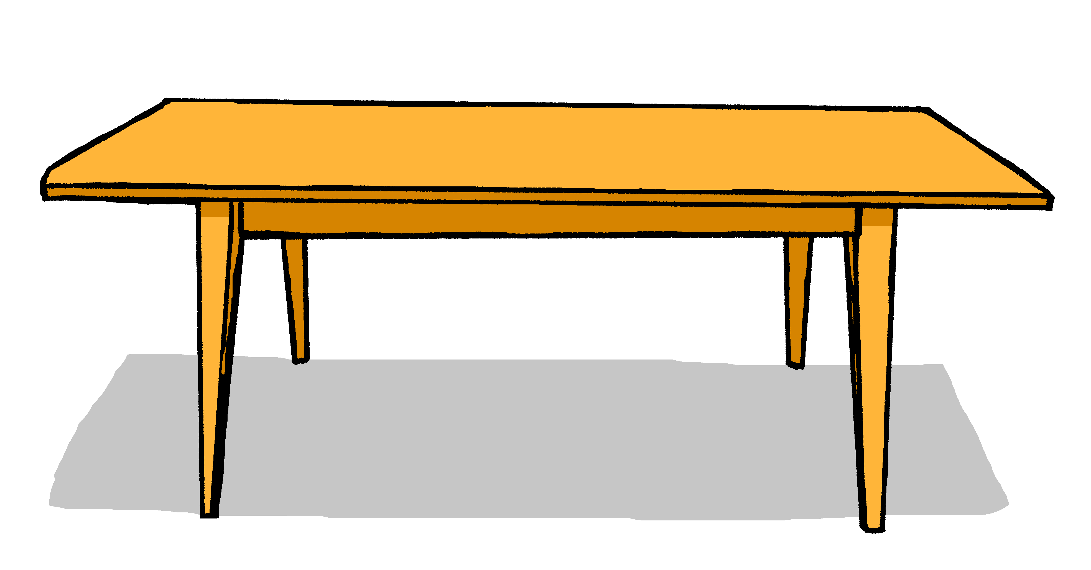

E Write the German word for ‘the’ in the gap.
1 | ________ Haus (nt)
2 | Du hast ________ Kuchen. (m)

F Write the German word for ‘my’ in the gap.

1 | Das ist ________ Film (m)
2 | Das ist ________ Tasche (f)

G Look at these male nouns. Write the female version of each noun in the table below.

 | Male noun | Female noun
1 | der Lehrer | die __________
 | the (male) teacher | the (female) teacher
2 | der Freund | die __________
 | the (male) friend | the (female) friend

H Write the plural version of each noun in the table below.

1 | ein Film | zwei __________
 | one (a) film | two films
2 | eine Flasche | zwei __________
 | one (a) bottle | two bottles

Total marks available (Grammar): 20

