Vocabulary
A For each question, put a cross (x) under the English meaning that matches what you hear.
You will hear each German word twice. Choose one correct answer only. (8)
 | A | B | C | D
1. | thing | present | notebook | board
 | ☐ | ☒ | ☐ | ☐
2. | I | you | she | he
 | ☐ | ☐ | ☐ | ☒
3. | to understand | to play | to win | to have
 | ☐ | ☐ | ☒ | ☐
4. | human being | friend | dog | woman
 | ☒ | ☐ | ☐ | ☐
5. | wrong | right | red | yellow
 | ☐ | ☒ | ☐ | ☐
6. | very | often | or | but
 | ☐ | ☒ | ☐ | ☐
7. | bag | water | song | word
 | ☐ | ☐ | ☐ | ☒
8. | to be | to think | to do, make | to know
 | ☐ | ☐ | ☒ | ☐

B For each question, put a cross (x) under the type of word you hear.
You will hear each German word twice. Choose one correct answer only. (4)
This word is a good example of …
 | A | B | C | D
1. | a number  ☒ | a place  ☐ | an activity  ☐ | a person  ☐
2. | a colour  ☐ | an animal  ☐ | a question word  ☐ | a greeting  ☒
3. | a person  ☐ | an object  ☒ | a food  ☐ | a place  ☐
4. | an activity  ☐ | a number  ☐ | a colour  ☒ | an animal  ☐

C Translate the underlined German word to complete each English sentence. (12)

1. Auf Wiedersehen Frau Schmidt! Goodbye Mrs Schmidt!
2. Ist er da? Is he there?
3. Was ist dein Lieblingstier? What is your favourite animal?
4. Er ist zu Hause. He is at home.
5. Der Tisch ist sehr klein. The table is very small.
6. Das Bild ist groβ und gelb. The picture is big and yellow.
7. Ich höre Musik. I listen to music.
8. Wie sagt man ‘German’? How do you say ‘German’?

D For each question, put a cross (x) under the word that best fits each category.
Choose one correct answer only. (5)
This word is a good example of …
 | A | B | C | D
1. a number | rot  ☐ | acht  ☒ | unten  ☐ | wie  ☐
2. a food | Kuchen  ☒ | Frau  ☐ | Punkt  ☐ | Lied  ☐
3. a country | Haus  ☐ | Wasser  ☐ | Fenster  ☐ | Deutschland  ☒
4. an activity | sein  ☐ | spielen  ☒ | haben  ☐ | verstehen  ☐
5. a place | Tafel  ☐ | Nummer  ☐ | Schule  ☒ | Herr  ☐

E Translate the underlined English words to complete the German sentence. (2 marks for items 2, 6, and 10 – one for word recall and one for capitalization of the noun. 2 marks for items 1 and 3 – one for each word) (15)
1. Yes, I am here. Ja, ich bin hier. (Write two words.)
2. Here is the dog. Hier ist der Hund. (Write one word.)
3. There are four things. Es gibt vier Dinge. (Write two words.)
4. Max sings. Max singt. (Write one word.)
5. Jakob has ten flowers. Jakob hat zehn Blumen. (Write one word.)
6. Where is my book? Wo ist mein Buch? (Write one word.)
7. I think. Ich denke. (Write one word.)
8. The example is false. Das Beispiel ist falsch. (Write one word.)
9. How’s it going? Not so good! Wie geht’s? Nicht so gut. (Write one word.)
10. You have the game. Du hast das Spiel. (Write one word.)

Total marks available (Vocabulary): 44
Grammar
A Put a (X) next to the person the sentence is about. (5)

1 | ☒ I  ☐ you _{[singular]}  ☐ she/he | … habe das Foto.
2 | ☐ I  ☒ you _{[singular]}  ☐ she/he | … lernst viel.
3 | ☐ I  ☒ you _{[singular]}  ☐ she/he | … bist toll.
4 | ☒ I  ☐ you _{[singular]}  ☐ she/he | … spiele Fußball.
5 | ☐ I  ☐ you _{[singular]}  ☒ she/he | … ist in Deutschland.

B Add a full stop (.) or a question mark (?) next to each sentence to show whether it is a statement or a question. (2)
?
1. Hört sie Musik
.
2. Du singst ein Lied

C Put a (X) next to the English meaning of the German sentence. (3)
1 | Das Buch ist nicht klar. | ☐ The book is clear.  ☒ The book is not clear.
2 | Du hast keinen Fuβball. | ☐ You have a football.  ☒ You don’t have a football.
3 | Das ist ein Bleistift. | ☒ That is a pencil.  ☐ That is not a pencil.

D Write the German word for ‘a’ in the gap. (2)
1 | eine Blume (f)
2 | Sie hat einen Tisch. (m) | 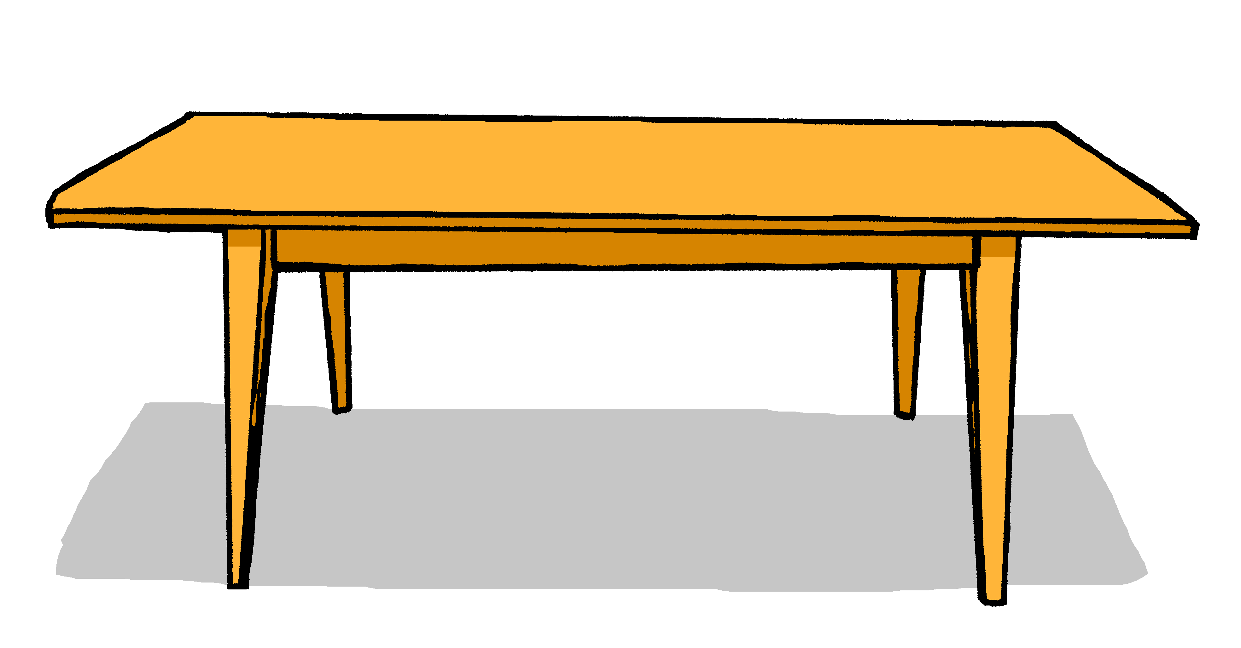

E Write the German word for ‘the’ in the gap (2)
1 | das Haus (nt)
2 | Du hast den Kuchen. (m)

F Write the German word for ‘my’ in the gap. (2)

1 | Das ist mein Film (m)
2 | Das ist meine Tasche (f)

G Look at these male nouns. Write the female version of each noun in the table below. (2)

 | Male noun | Female noun
1 | der Lehrer | die Lehrerin
 | the (male) teacher | the (female) teacher
2 | der Freund | die Freundin
 | the (male) friend | the (female) friend

H Write the plural version of each noun in the table below. (2)

1 | ein Film | zwei Filme
 | one (a) film | two films
2 | eine Flasche | zwei Flaschen
 | one (a) bottle | two bottles

Total marks available (Grammar): 20

