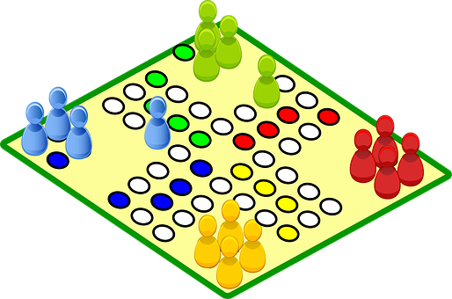
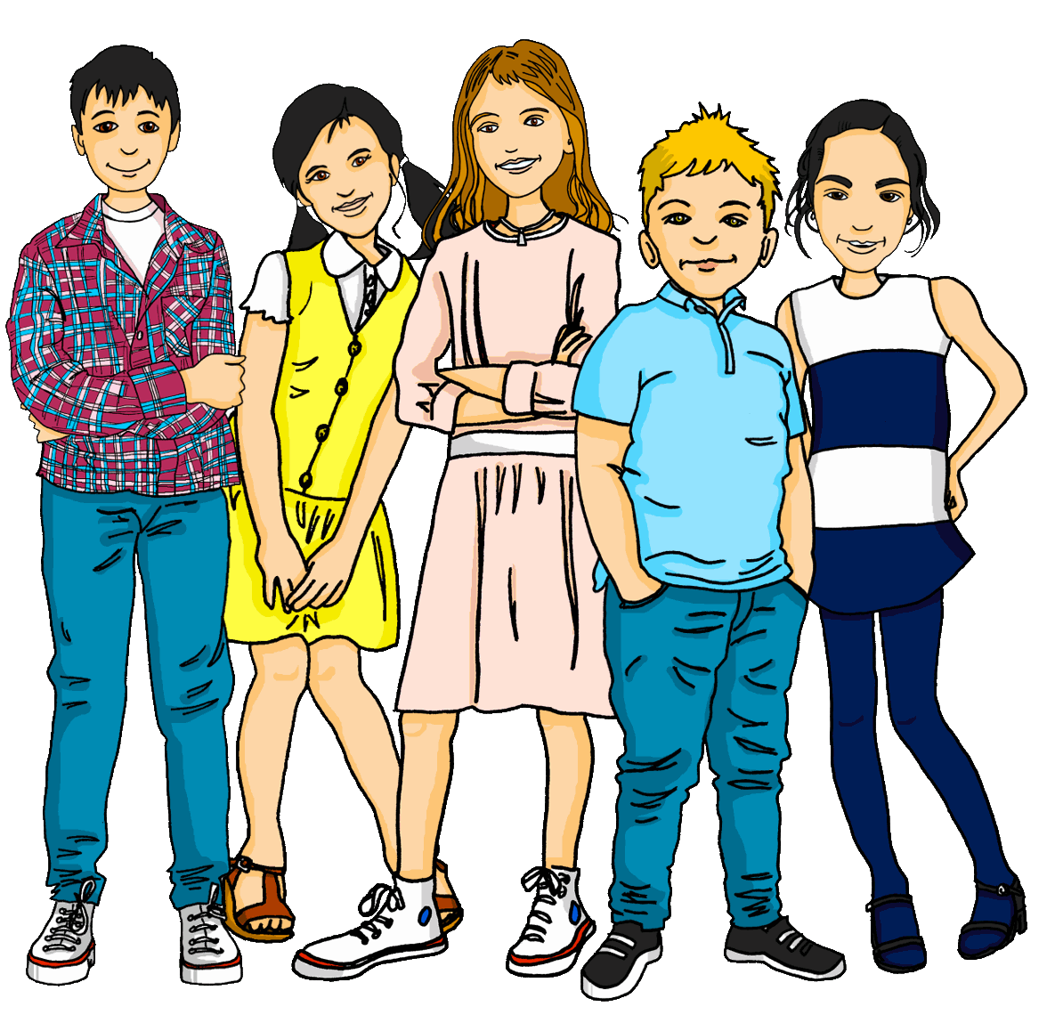
Vocabulary
A For each question, put a cross (x) under the English meaning that matches what you hear.
You will hear each German word twice. Choose one correct answer only. (8)
 | A | B | C | D
1. | ball | clothing | partner | cat
 | ☐ | ☐ | ☐ | ☐
2. | I | you | she | he
 | ☐ | ☐ | ☐ | ☐
3. | to need | to play | to receive | to have
 | ☐ | ☐ | ☐ | ☐
4. | watch | jacket | task | tree
 | ☐ | ☐ | ☐ | ☐
5. | wrong | difficult | white | bad
 | ☐ | ☐ | ☐ | ☐
6. | how ? | clear | good | easy
 | ☐ | ☐ | ☐ | ☐
7. | pupil | Mr | woman | man
 | ☐ | ☐ | ☐ | ☐
8. | one | six | zero | four
 | ☐ | ☐ | ☐ | ☐

B For each question, put a cross (x) under the type of word you hear.
You will hear each German word twice. Choose one correct answer only. (4)
This word is a good example of …
 | A | B | C | D
1. | a number  ☐ | a place  ☐ | an activity  ☐ | a person  ☐
2. | a colour  ☐ | an animal  ☐ | a question word  ☐ | a building  ☐
3. | a person  ☐ | a question  ☐ | a food  ☐ | a place  ☐
4. | an activity  ☐ | a number  ☐ | a colour  ☐ | an animal  ☐

C Translate the underlined German word to complete each English sentence. (12)

1. Ich weiß (es) nicht, Herr Lehmann. _______________________, Mr Lehmann.
2. Wo ist England? ________________ is England?
3. Was ist dein Lieblingssong? What is your __________________________?
4. Die Farbe ist grün, nicht wahr? The colour is green, ___________________?
5. Meine Aufgabe ist total einfach. My task is ___________________ easy.
6. Schwarz oder grau? Black ________________ grey?
7. Ich brauche ein Blatt. I _______________ a sheet.
8. Guten Morgen, Frau Müller! _______________, Mrs Müller!

D For each question, put a cross (x) under the word that best fits each category.
Choose one correct answer only. (5)
This word is a good example of …
 | A | B | C | D
1. a number | lang  ☐ | sieben  ☐ | neu  ☐ | tschüss  ☐
2. a person | Partner  ☐ | Text  ☐ | Hausaufgabe  ☐ | Liste  ☐
3. a country | Ort  ☐ | Ding  ☐ | Butterbrot  ☐ | die Schweiz  ☐
4. an activity | haben  ☐ | schreiben  ☐ | es hat  ☐ | sein  ☐
5. a description | aber  ☐ | auch  ☐ | rund  ☐ | und  ☐

E Translate the underlined English words to complete the German sentence. (2 marks for items 2, 6, 10 – one for word recall and one for capitalization of the noun. 2 marks for items 1 and 3 – one for each word) (15)
1. No, you are there. ________, du ________ da. (Write two words.)
2. Here is the mistake. Hier ist der __________. (Write one word.)
3. There is a prize. _________ einen Preis. (Write two words.)
4. Mia writes. Mia ______________. (Write one word.)
5. Luca has five stories. Luca hat ________ Geschichten. (Write one word.)
6. What is the problem? Was ist das ____________? (Write one word.)
7. I make that. Ich ____________ das. (Write one word.)
8. Yes, that is right. Ja, das ist ___________. (Write one word.)
9. Who is the person? __________ ist die Person? (Write one word.)
10. She has the letter. Sie hat den ___________. (Write one word.)

Total marks available (Vocabulary): 44
Grammar
A Put a (X) next to the person the sentence is about. (5)

1 | ☐ I  ☐ you _{[singular]}  ☐ she/he | … hast eine Katze. | 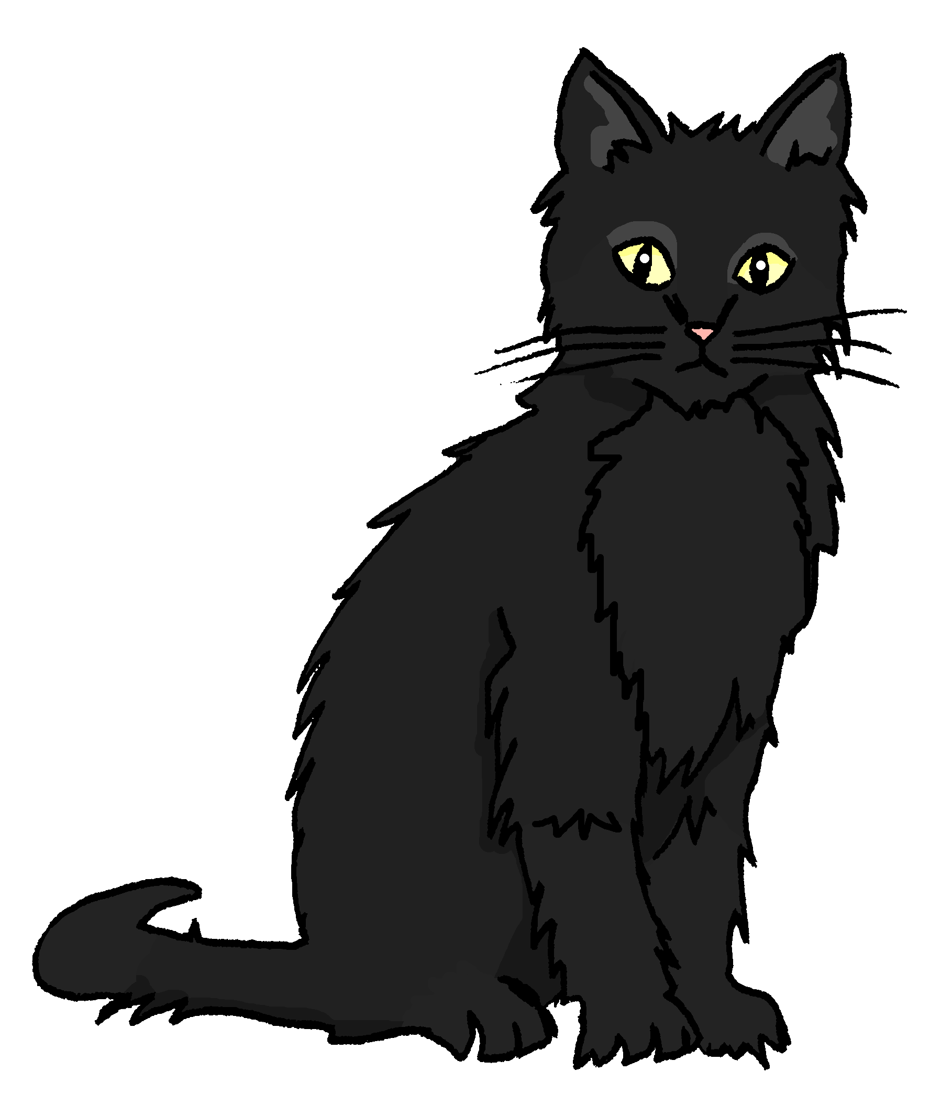
2 | ☐ I  ☐ you _{[singular]}  ☐ she/he | … benutze das Papier.
3 | ☐ I  ☐ you _{[singular]}  ☐ she/he | … ist wunderbar.
4 | ☐ I  ☐ you _{[singular]}  ☐ she/he | … brauchst Hilfe.
5 | ☐ I  ☐ you _{[singular]}  ☐ she/he | … bin in der Schweiz.

B Add a full stop (.) or a question mark (?) next to each sentence to show whether it is a statement or a question. (2)

1. Bekommst du eine Karte

2. Er spielt zu Hause

C Put a (X) next to the English meaning of the German sentence. (3)
1 | Das ist nicht das Haus. | ☐ That is the house.  ☐ That is not the house.
2 | Ich habe keine Farbe. | ☐ I have a colour.  ☐ I don’t have a colour.
3 | Das ist eine Nummer. | ☐ That is a number.  ☐ That is not a number.

D Write the German word for ‘a’ in the gap. (2)
1 | ___________ Spiel (n)
2 | Er hat ___________ Apfel. (m)

E Write the German word for ‘the’ in the gap (2)
1 | ___________ Gruppe (f)
2 | Du hast ___________ Computer. (m)

F Write the German word for ‘your’ in the gap. (2)

1 | Das ist ___________ Fahrrad. (n) | 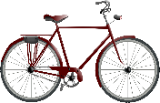
2 | Das ist ___________ Idee. (f)

G Look at these male nouns. Write the female version of each noun in the table below. (2)

 | Male noun | Female noun
1 | der Schüler | die ___________________
 | the (male) pupil | the (female) pupil
2 | der Spieler | die ___________________
 | the (male) player | the (female) player

H Write the plural version of each noun in the table below. (2)

1 | ein Baum | zwei _______________
 | one (a) tree | two trees
2 | eine Jacke | drei _______________
 | one (a) jacket | three jackets

Total marks available (Grammar): 20

