Vocabulary
A For each question, put a cross (x) under the English meaning that matches what you hear.
You will hear each German word twice. Choose one correct answer only. (8)
 | A | B | C | D
1. | ball | clothing | partner | cat
 | ☐ | ☒ | ☐ | ☐
2. | I | you | she | he
 | ☒ | ☐ | ☐ | ☐
3. | to need | to play | to receive | to have
 | ☐ | ☐ | ☒ | ☐
4. | watch | jacket | task | tree
 | ☒ | ☐ | ☐ | ☐
5. | wrong | difficult | white | bad
 | ☐ | ☒ | ☐ | ☐
6. | how ? | clear | good | easy
 | ☐ | ☒ | ☐ | ☐
7. | pupil | Mr | woman | man
 | ☐ | ☐ | ☐ | ☒
8. | one | six | zero | four
 | ☐ | ☐ | ☒ | ☐

B For each question, put a cross (x) under the type of word you hear.
You will hear each German word twice. Choose one correct answer only. (4)
This word is a good example of …
 | A | B | C | D
1. | a number  ☒ | a place  ☐ | an activity  ☐ | a person  ☐
2. | a colour  ☐ | an animal  ☐ | a question word  ☐ | a building  ☒
3. | a person  ☐ | a question  ☒ | a food  ☐ | a place  ☐
4. | an activity  ☒ | a number  ☐ | a colour  ☐ | an animal  ☐

C Translate the underlined German word to complete each English sentence. (12)
Note: the (es) is not credit-bearing.

1. Ich weiß (es) nicht, Herr Lehmann. I don’t know, Mr Lehmann.
2. Wo ist England? Where is England?
3. Was ist dein Lieblingssong? What is your favourite song?
4. Die Farbe ist grün, nicht wahr? The colour is green, isn’t it?
5. Meine Aufgabe ist total einfach. My task is totally easy.
6. Schwarz oder grau? Black or grey?
7. Ich brauche ein Blatt. I need a sheet.
8. Guten Morgen, Frau Müller! Good morning, Mrs Müller!

D For each question, put a cross (x) under the word that best fits each category.
Choose one correct answer only. (5)
This word is a good example of …
 | A | B | C | D
1. a number | lang  ☐ | sieben  ☒ | neu  ☐ | tschüss  ☐
2. a person | Partner  ☒ | Text  ☐ | Hausaufgabe  ☐ | Liste  ☐
3. a country | Ort  ☐ | Ding  ☐ | Butterbrot  ☐ | die Schweiz  ☒
4. an activity | haben  ☐ | schreiben  ☒ | es hat  ☐ | sein  ☐
5. a description | aber  ☐ | auch  ☐ | rund  ☒ | und  ☐

E Translate the underlined English words to complete the German sentence. (2 marks for items 2, 6, 10 – one for word recall and one for capitalization of the noun. 2 marks for items 1 and 3 – one for each word) (15)
1. No, you are there. Nein, du bist da. (Write two words.)
2. Here is the mistake. Hier ist der Fehler. (Write one word.)
3. There is a prize. Es gibt einen Preis. (Write two words.)
4. Mia writes. Mia schreibt. (Write one word.)
5. Luca has five stories. Luca hat fünf Geschichten. (Write one word.)
6. What is the problem? Was ist das Problem? (Write one word.)
7. I make that. Ich mache das. (Write one word.)
8. Yes, that is right. Ja, das ist richtig. (Write one word.)
9. Who is the person? Wer ist die Person? (Write one word.)
10. She has the letter. Sie hat den Brief. (Write one word.)

Total marks available (Vocabulary): 44
Grammar
A Put a (X) next to the person the sentence is about. (5)

1 | ☐ I  ☒ you _{[singular]}  ☐ she/he | … hast eine Katze. | 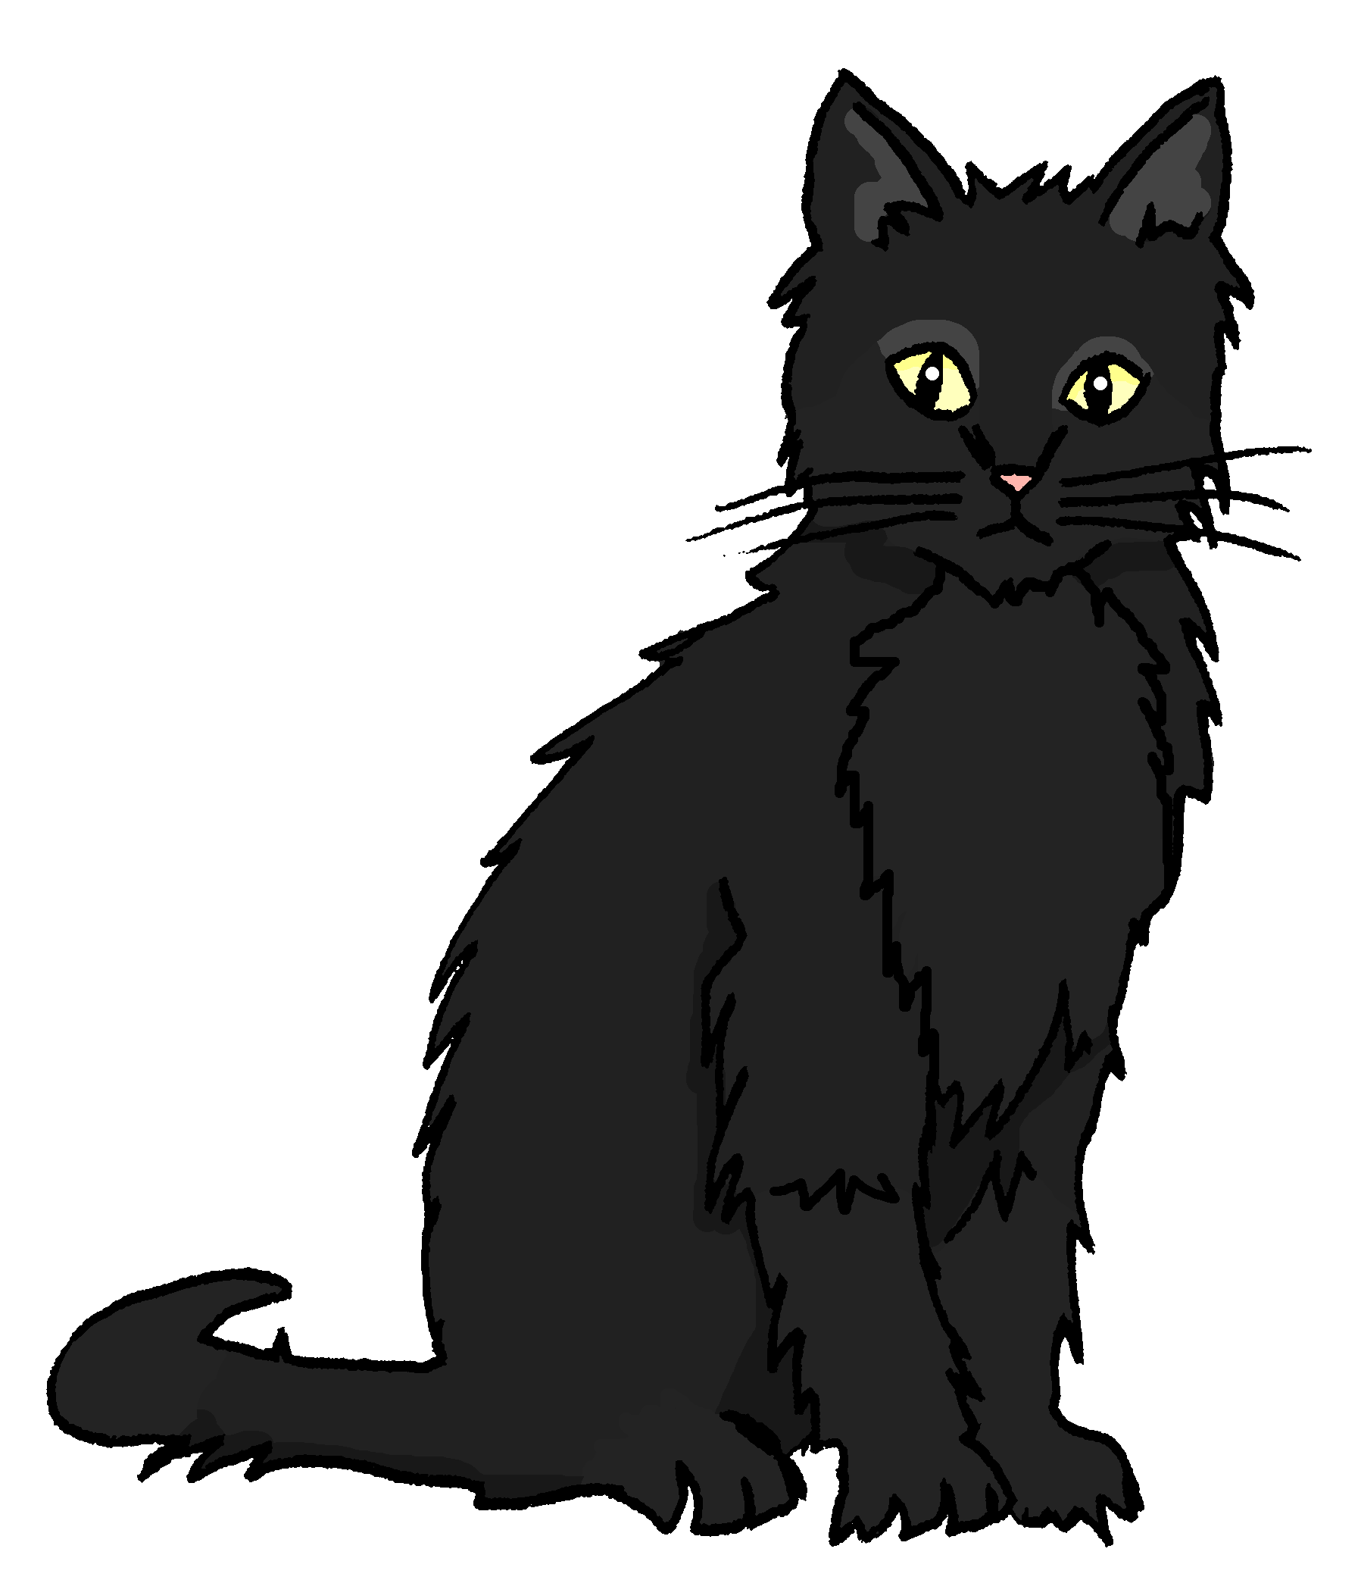
2 | ☒ I  ☐ you _{[singular]}  ☐ she/he | … benutze das Papier.
3 | ☐ I  ☐ you _{[singular]}  ☒ she/he | … ist wunderbar.
4 | ☐ I  ☒ you _{[singular]}  ☐ she/he | … brauchst Hilfe.
5 | ☒ I  ☐ you _{[singular]}  ☐ she/he | … bin in der Schweiz.

B Add a full stop (.) or a question mark (?) next to each sentence to show whether it is a statement or a question. (2)
?
1. Bekommst du eine Karte
.
2. Er spielt zu Hause

C Put a (X) next to the English meaning of the German sentence. (3)
1 | Das ist nicht das Haus. | ☐ That is the house.  ☒ That is not the house.
2 | Ich habe keine Farbe. | ☐ I have a colour.  ☒ I don’t have a colour.
3 | Das ist eine Nummer. | ☒ That is a number.  ☐ That is not a number.

D Write the German word for ‘a’ in the gap. (2)
1 | ein Spiel (n) | 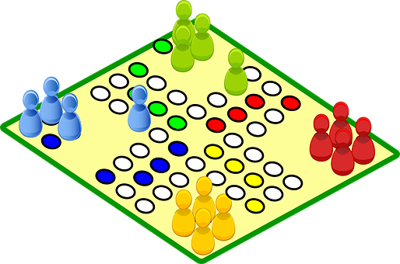
2 | Er hat einen Apfel. (m)

E Write the German word for ‘the’ in the gap (2)
1 | die Gruppe (f) | 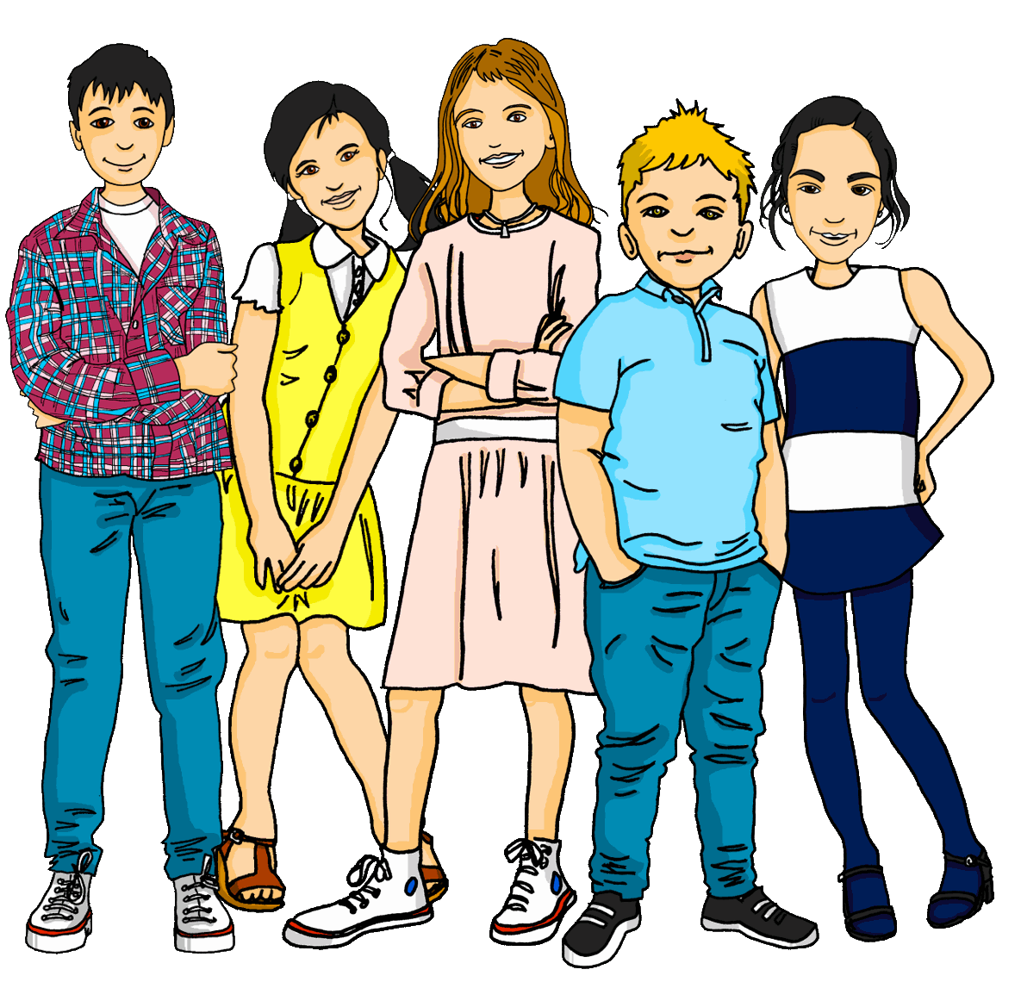
2 | Du hast den Computer. (m)

F Write the German word for ‘your’ in the gap. (2)

1 | Das ist dein Fahrrad. (n) | 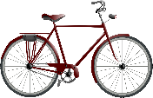
2 | Das ist deine Idee. (f)

G Look at these male nouns. Write the female version of each noun in the table below. (2)

 | Male noun | Female noun
1 | der Schüler | die Schülerin
 | the (male) pupil | the (female) pupil
2 | der Spieler | die Spielerin
 | the (male) player | the (female) player

H Write the plural version of each noun in the table below. (2)

1 | ein Baum | zwei Bäume
 | one (a) tree | two trees
2 | eine Jacke | drei Jacken
 | one (a) jacket | three jackets

Total marks available (Grammar): 20

