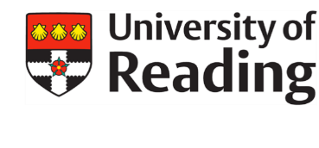
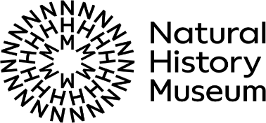

Collaborative Research Fellowship Information Day 2024 Application Form
The strategic partnership between the University of Reading and the Natural History Museum offers unique opportunities for collaborative research across a broad range of disciplines. This event aims to attract interest from high-potential early-career researchers who may wish to apply for an independent research fellowship to be held at either organisation.
Applicants are asked to complete a short application form to register their interest in attending the Information Day and outline their proposed areas of research. Applicants must be considering a fellowship which has the potential to lead to meaningful research in an area of study which is of relevance to both organisations.
Projects which could build meaningful collaborations between the two organisations, and which have strong potential in the sustainability and environmental science area, are strongly encouraged. We are also keen to support applications for research projects which make the most of the extensive world-class collections at both institutions.
Some key areas of strength and research themes for both institutions can be found on the partnership’s website.
Please also attach a brief CV, confirming your PhD award date (or anticipated date) and where applicable how many years of postdoctoral experience you have, and email both the CV and this form to NHM-UoR-Partnership@nhm.ac.uk by Sunday 18th February 2024.

Please outline your current and/or potential future research interests and topics
(max 200 words)
Please state your reasons for wanting to undertake research at the University of Reading and/or at the Natural History Museum. Feel free to list any members of staff, themes, or divisions you would like to engage with at the event (max 200 words)

