**What is a Panic Attack?**

A panic attack is a sudden and overwhelming surge of fear and anxiety that can make you feel that your physical health is in danger or that you may die. Panic attacks are often terrifying and can last for between 5 to 20 minutes. They can seem to happen for no apparent reason and they may cause you to feel a range of unpleasant physical and emotional sensations**. Panic attacks may be very frightening but they are not dangerous or harmful.**

**Panic Attack Symptoms**

**Physical Symptoms:**

* Sweating.
* Fast heartbeat.
* Shaking or trembling.
* Shortness of breath or difficulty breathing.
* Feeling dizzy, lightheaded or faint.
* Pain or pressure in your chest.
* Hot flushes or chills.
* Tingling or numbness in body.
* Feeling sick or stomach pains.
* Choking sensations.

**What You Might Think and Feel:**

* Frightened.
* That your physical health is in danger or that you may die.
* That something awful is going to happen.
* Have thoughts that you are going mad or losing control.
* Feeling that things around you are strange and unreal.
* Have a strong desire to escape to safety.

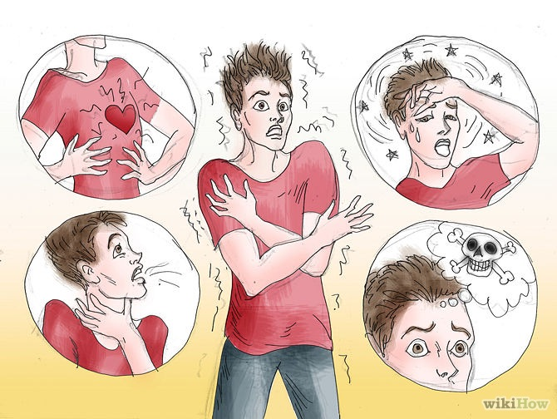

**How common are they?** Panic attacks are very common. For some people it may be a one-time occurrence in which the cause of fear is apparent, whilst others may experience repeated episodes for no clear reason.

**What causes it?** A panic attack can be triggered by a number of things. It may arise from stress, for example during exam time, or from doing something that makes you feel apprehensive, such as starting a new school.

**What keeps panic going?** When you start to feel ‘panicky’ you tend to focus your attention on the anxious bodily sensations that you are feeling. You misinterpret these symptoms as something more serious (e.g. “I’m having a heart attack!”). This increases your anxiety, which in turn, increases your physical symptoms leading to a panicked state. Your fear of having another attack keeps your anxiety high and you tend to have an increased focus on physical sensations. The physical symptoms and anxious thoughts create a vicious cycle that keeps panic attacks coming back (see Fig below).

**The Cycle of Panic**

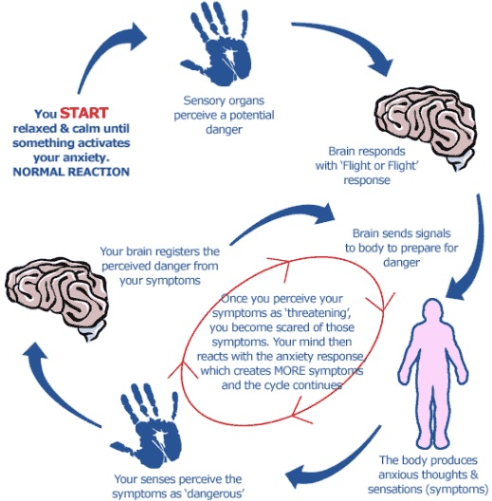

**Fight or Flight Response**

To understand panic better, it is helpful to understand a bit about anxiety. Anxiety is a survival instinct that has evolved over millions of years. It is a normal alarm response that switches on when it thinks you are in danger and it serves to protect us. This automatic alarm response causes certain physical responses in our bodies, gearing us up to either run for our lives or to defend ourselves. This alarm response is called the **'fight or flight'** response. Everyone has experienced the feeling of anxiety and panic at some point in their lives. For example, if a dangerous dog approached you or if you were sat in an exam and you realised that you didn’t know any of the answers to the questions, you would most likely experience a feeling of panic. It is normal to feel a sense of panic in such situations.

Sometimes though, it is possible to experience this intense fear and alarm response when there is no actual danger. In such circumstances, a panic attack is like a false alarm, sending threat messages to your brain with the intention of fuelling your body to 'fight or flight' when there is no real danger present. The alarm response cannot distinguish between something that might harm you (e.g. a dangerous dog) and something that won’t harm you (e.g. going to the cinema). Sometimes the alarm response just switches itself on without you knowing why. It works hard to protect you, even when you may not need protecting. So if there is no threat to run away or defend yourself from, there is nothing to burn all that energy up and that’s the reason why you experience unpleasant symptoms when you are having a panic attack.

**Panic disorder is where you have recurring and regular panic attacks, often for no apparent reason.**

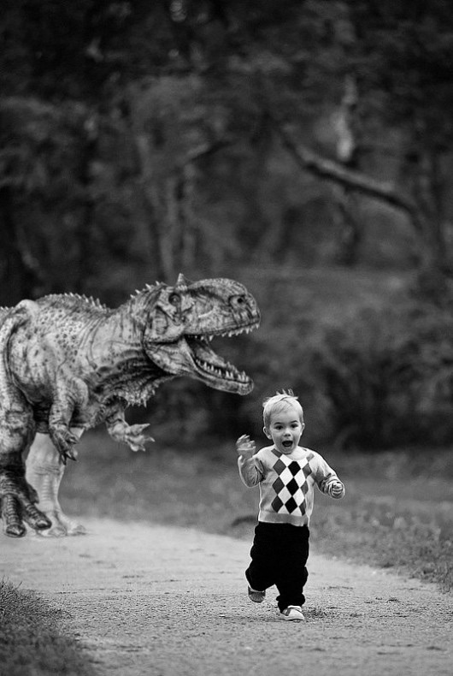

**Biological Reactions of Fight or Flight**

When the fight or flight response is activated, it releases adrenaline into the body to make the heart beat faster and more powerfully so that more blood and oxygen can be pumped around the body. This can cause the sensation of your heart beating faster and feelings of breathlessness. Faster breathing allows more oxygen to get into your body. Blood is pumped into the muscles so that they can work harder, gearing you up to either fight or run away. Blood is drained away from the brain which can cause you to feel light-headed and away from the stomach which can give you that 'butterflies' feeling. The pupils in your eyes get larger to help you to see better. Muscles become more tense in preparation for action. This tension can cause your muscles to ache, tremble or shake, particularly in your hands, arms and legs. The increased tension in your body can also cause headaches. Sweating allows your body to cool itself down so it does not overheat if it has to fight or flight. This all happens quickly and automatically.

**What are the Effects of Panic attacks?**

**Avoidance:** You may fear having a panic attack so much that you avoid certain situations where you feel that they are likely to occur or have occurred in the past. You may also avoid situations from which it is difficult to escape, such as public transport. Some people may even find it difficult to leave home (agoraphobia) because no place feels safe. By avoiding or escaping panic attacks you never find out that nothing bad was going to happen. Avoidance keeps the cycle of panic going.

**Safety Behaviours:** You may find yourself using ‘safety behaviours’ to prevent or manage an attack (e.g. making sure you are seated near the exit at the cinema, checking your pulse or seeking reassurance from a friend that you are okay). These may initially seem like useful strategies but you may start to become dependent on them. Safety behaviours often become unhelpful and can increase your anxiety when you are unable to use them.

**Seek Help:** You may feel so scared during an attack that you may call an ambulance or seek help from A&E.

**Mood:** Living with the constant fear of having further panic attacks can trigger symptoms of low mood or depression. You may also become isolated and lose confidence in your ability to manage alone.

**Strategies to Reduce Panic Attacks**

As you have read, there are very real reasons why your body feels the way it does when you are having a panic attack. But the good news is that there are also things that you can do to reduce these unpleasant feelings. **Cognitive behavioural therapy (CBT)** is an effective and clinically proven treatment for panic attacks and panic disorder.CBT strategies include relaxation and breathing training, cognitive restructuring and exposure. Please keep in mind that these strategies may not work straight away. They will need to be practiced in order for you to see the benefits. You may find some of the strategies more helpful than others, so take the time to explore which ones work best for you. It is best to practice these techniques when you are not anxious so that it will be easier for you to use them when you are having an attack. **Remember that** **panic attacks are not harmful and are very treatable.**

**Relaxation:**

Relaxation allows us to counter the effects of ‘fight or flight’ by switching off the sympathetic nervous system (which is activated during fight or flight) and turning on the parasympathetic nervous system (which reduces heart rate and slows down our breathing), allowing the body to return to a calmer state. Relaxation can include everyday things such as reading, yoga, exercise, or listening to music. More specific relaxation techniques include progressive muscle relaxation (tensing and releasing muscles), meditation and guided imagery or visualisation. Relaxation is a skill that has to be learnt, so it is important to practice regularly. Relaxation techniques are an effective way of allowing our physical and mental tension to be released and gaining control of our anxiety.

**Links:** A first Steps Guide to improving Relaxation: [www.firststeps-surrey.nhs.uk](http://www.firststeps-surrey.nhs.uk)

How to do Progressive Muscle Relaxation: [www.anxietybc.comm](http://www.anxietybc.comm)

Guided Visualisation & Imagery for Self-Help: [www.getselfhelp.co.uk](http://www.getselfhelp.co.uk)

**Calm Breathing:**

Calm breathingcan help with the panic symptoms of over breathing or hyperventilating by slowing down your breathing. Try the following:

* Place one hand on your upper chest and the other on your stomach.
* Take a deep breath through your nose while counting to five.
* The hand on your chest should remain still while you breathe in and the one on your stomach should rise with your breath.
* When you reach the count of five, breathe out slowly through your mouth.
* Focus your thinking on the word ‘calm.’

**Links:** Calm Breathing: [www.anxietybc.com](http://www.anxietybc.com)

Mindful breathing: [www.getselfhelp.co.uk](http://www.getselfhelp.co.uk)

**Distraction/Grounding Techniques:**

Focusing on bodily sensations only serves to increase your anxiety. It is better to focus on things going on in your external environment rather than internally inside you. There are lots of ways you can use distraction to reduce your symptoms, such as counting or doing sums in your head; recalling the lyrics of a song or saying the alphabet backwards; focusing your attention on what you can see (e.g. watch people around you); say calming statements (e.g. “I can control this. This feeling will pass”); or think of a safe place (see link above for Imagery for Self Help). The aim is to take your focus off your bodily symptoms and on to something else**.**

**Links:** Attention! Distract Yourself: [www.getselfhelp.co.uk](http://www.getselfhelp.co.uk)

Detaching from emotional pain (Grounding Techniques): [www.e-tmf.org](http://www.e-tmf.org)

**Cognitive Restructuring/Challenging your Thoughts:**

Cognitive restructuring aims to increase your awareness of the thoughts and beliefs that are maintaining or triggering your panic attacks. Our thoughts play a big part in affecting the way we feel, so thinking in unhelpful ways (e.g. “I can’t cope with this”) only serves to increase our anxiety. It makes sense then, that thinking in more realistic and helpful ways will help us to feel better and more in control (e.g. “I can cope with this….my anxiety won’t last forever”). A panic diary can help you to spot thinking errors (e.g. are you overestimating the chances of something bad happening or assuming that you can’t cope with it?). It is a useful way of identifying how your thoughts and beliefs are triggering and fuelling your panic attacks.

Once thinking errors have been identified you can then learn to challenge them and replace them with more realistic/alternative thoughts. This can be achieved by asking yourself the following questions: What am I thinking right now? What is the evidence for and against my anxious thoughts? Are my thoughts realistic? Is there another way of looking at this? What am I worried will happen? Am I underestimating my ability to cope? What are the advantages/disadvantages of thinking in this way? What other outcomes are possible?

It is helpful to write your realistic thoughts down and keep them with you, as it can be hard to recall them when you are having an attack. Once you have learned that nothing bad is going to happen during a panic attack, further episodes of panic become less frightening. Challenging your negative thoughts is not an easy skill to learn; it requires practice and patience to get it right but it is worth persevering with if you want to gain control over your anxiety.

**Links:** Realistic thinking [www.anxietybc.com](http://www.anxietybc.com)

Panic diary: [www.getselfhelp.co.uk](http://www.getselfhelp.co.uk)

Unhelpful Thinking Styles [www.psychologytool.org](http://www.psychologytool.org);

Finding Alternative Thoughts & Fact or Opinion [www.getselfhelp.co.uk](http://www.getselfhelp.co.uk)

**Exposure: Challenge Safety Behaviours & Avoidance**

Altering your behaviour is one of the most effective ways of reducing feelings of panic. Avoidance, escape and safety behaviours only serve to maintain and increase anxiety. It is far better to stay in the situation (in vivo exposure) where your attack has occurred and ride it out. This way you are able to test out what really happens (i.e. that your panic feelings will pass) rather than what you fear will happen (e.g. “I will pass out”)**.** Exposure essentially means exposing yourself to situations that are likely to trigger a panic attack

without engaging in avoidance, escape or using safety behaviours. It is best to start with the least anxiety-provoking situations and then move on to the most-anxiety provoking situations (graded exposure). Exposure needs to be repeated several times until your anxiety diminishes. Exposure provides you with the evidence that panic attacks are not harmful.

**Links**: Facing Your Fears: Exposure [www.anxietybc.com](http://www.anxietybc.com);

Exposure homework sheet [www.getselfhelp.co.uk](http://www.getselfhelp.co.uk)

Interoceptive exposure (exposure to internal sensations) helps you to overcome your fear of the physical sensations of a panic attack by getting you to try out a variety of exercises that elicit similar bodily sensations of a panic attack, such as fast heart rate and dizziness. An example of such an exercise would be to run up and down some stairs quickly to produce feelings of breathlessness, racing heart and heavy legs. You will then be asked to use the strategies that you have learnt (e.g. calm breathing or cognitive restructuring) to reduce and control the attack. Each exposure tasks allows you to become more tolerant and less afraid of the bodily sensations produced during a panic attack. Catastrophic thinking and misinterpretations will also reduce and you will gain a greater sense of control over your panic.

**Links:** Introceptive exposure exercises [www.psychology.tools/panic.hyml](http://www.psychology.tools/panic.hyml)).

Exposure exercises for Panic disorder [www.anxietybc.com](http://www.anxietybc.com)

**Self Help Resources for Panic Attacks**

**Websites:**

* **Panic Stations: Coping with Panic Attacks.** [**www.cci.health.wa.gov.au**](http://www.cci.health.wa.gov.au)
* **Panic Self-Help Guide.** [**www.ntw.nhs.uk**](http://www.ntw.nhs.uk)
* **Self-Help Strategies for Panic Disorder: Anxiety BC.** [**www.anxietybc.com**](http://www.anxietybc.com)
* **Panic Disorder:** [**www.teenmentalhealth.org**](http://www.teenmentalhealth.org)
* **Controlling your Panic Attacks:** [**www.childline.org.uk**](http://www.childline.org.uk)
* **Panic Attack – Tips:** [**www.mind.org.uk**](http://www.mind.org.uk)
* **Coping with Panic: Dr Charles Young.** [**www.cpft.nhs.uk**](http://www.cpft.nhs.uk)
* **Panic: Moodjuice Self-Help Guide.** [**www.moodjuice.scot.nhs.uk**](http://www.moodjuice.scot.nhs.uk)
* **Panic attacks. Dr Jim White.** [**www.GlasgowSTEPS.com**](http://www.GlasgowSTEPS.com)
* **No Panic.** [**www.nopanic.org.uk**](http://www.nopanic.org.uk)
* **No More Panic.** [**www.nomorepanic.co.uk**](http://www.nomorepanic.co.uk)

**Books:**

* **Panic Disorder: The Facts. Stanley Rachman & Padmel De Silva (1996). Oxford University Press, 2009.**
* **Overcoming Panic: A Self-Help Guide using Cognitive Behavioural Techniques. Derrick Silove & Vijaya Manicavasagar. Robinson, 1997.**
* **The Anxiety and Phobia Workbook. Edmund J. Bourne. New Harbinger, 2015.**

**Written by Susan Campbell April, 2015**